Some Comments on: “Response to MCM/2010/SWG-PEL/50: Suggestions for improving the penguin model” (Altwegg and Crawford: MARAM IWS/DEC10/PA/P8)

Doug S Butterworth and William Robinson

MARAM (Marine Resource Assessment and Management Group)
Department of Mathematics and Applied Mathematics
University of Cape Town
November 2010

For readers’ convenience, comments have been entered after the duplication of the paragraphs in MARAM IWS/DEC10/PA/P8. The comments are given in italics.

In some instances comments have been given in relation to updated analyses in MARAM IWS/DEC10/PA/P6 rather than to the earlier document and associated analyses (MARAM IWS/DEC10/PA/P2 and P1 respectively) upon which Altwegg and Crawford based their responses in MARAM IWS/DEC10/PA/8.

- The main concern is that the model structure essentially forces much of the unmodelled heterogeneity onto adult survival. A symptom of this structural problem was that adult survival rates were pushed towards the set boundary especially for Robben Island when the population there grew faster than what the model could reproduce with realistic parameter estimates. This concern is still not being addressed. The reaction was to cast the same model in a Bayesian framework, which conceals the symptoms a bit better, especially when the posterior densities are summarized using quantiles rather than giving proper credible intervals. It is possible to model the large increase in penguins at Robben Island and in the Western Cape in the late 1990s and early 2000s, if account is taken of the likely non-participation of breeders in earlier years (see the simple model of Crawford 2007).

These problems are not as evident for the most recent implementation of the model in MARAM IWS/DEC10/PA/P6 (see Figs 2 and 13 thereof) – this is an implementation that assumes no relative undercount of juveniles in the moult counts. They are lessened further if such a relative undercount is assumed or if there was immigration over this period – both factors to be considered in sensitivity tests. Equally MLEs on constraint boundaries (though this does occur for the model of MARAM IWS/DEC10/PA/P6) can arise from the effects of observation error, so do not necessarily reflect model misspecification. This is an issue listed for further discussion during the workshop. A number of problems with the simple model of Crawford (2007) are documented in Butterworth and Plaganyi: SWG/EAF/SEABIRDS/13 APR/04 and SWG/EAF/SEABIRDS/26APR07/02.

- A related comment made earlier, and also essentially ignored so far, is that the model does not properly account for the observation process. Using an unstructured error term to mop up all unmodelled variability has no longer been state-of-the art in statistical ecology for more than a decade now (see e.g. Clark 2007). For the integrated models, particular attention has to be paid to the observation process, which varies among years, age classes, and other factors.

No information that would allow this has been provided by those conducting the counts. Some evaluations of annual variances in moult counts were conducted in MARAM IWS/DEC10/PA/BG1, but the evident coarseness of the results is such as would not seem to merit attempting year-specific weighting of the moult count data in the penguin population model fits. Furthermore given that the well behaved nature of the residuals for the MPLEs for the moult count data shown in Figs 10 and 11 of the most recent analysis in MARAM IWS/DEC10/PA/P6, key results would seem unlikely to be sensitive to more sophisticated treatment of these aspects.

- Critical technical information is missing for all Bayesian analyses that have been seen by the authors. We assume they used Markov Chain Monte Carlo but how many chains were run, for how long, and how did they test convergence?

The MCMC option for Bayesian analysis available in ADMB has been used throughout. Typically chains of length 6 million with a burn in of 1 million were implemented. Traces were checked visually for evidence of non-convergence (see Fig. 1 below for example of what is likely the least stable parameter in the analyses of MARAM IWS/DEC10/PA/P6), but none was evident. Note that these past computations were components of exploratory analyses. At a subsequent stage of finalization of these analyses, full diagnostic checking for convergence will be undertaken.

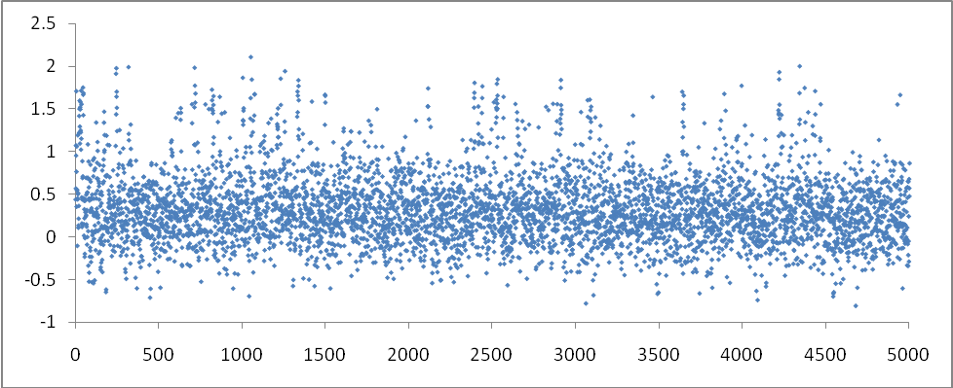
Fig 1: Trace for the slope parameter μ relating survival to sardine abundance with thinning every 1000 realisations.

- The Robinson et al. (2010) model merges breeding success and immature survival, which does not make it easy to compare model output with measured values.

These factors act in concert in respect of their impact on the penguins’ population dynamics and data used in the current population model fit (specifically the proportion of juveniles in the moult counts). It is not necessary or conventional to distinguish them in such models unless data are available which pertain to one but not both factors. The only such data available are those related to fledging success in Table 5 of MARAM IWS/DEC10/PA/P4. They are very limited for Dassen Island (values for 6 years only). There are rather more values available for Robben Island, though for two non-overlapping non-comparable series. Furthermore we understand that the Robben Island data reflect results for only the first of two possible breeding attempts. Nevertheless it would be worthwhile discussing whether these data might be used in fitting the Robben Island model. Since there are no data related to immature survival of which we are aware, this would not require any change to the existing model in respect of distinguishing the two factors, as the indices of fledging success would be taken to be proportional to the annual reproductive success parameter H_{y} in the model in any such exercise.

- The Robinson et al. (2010) model used an unrealistically high value of carrying capacity for Dassen Island, but the modelers now propose to remove density-dependence, although food limitation is likely to make it a factor (see Crawford et al. 2007).

As mentioned in response 14) on pg 7 of MARAM IWS/DEC10/PA/P2, this is intended for a reference case model which should be parsimonious. As also stated there, sensitivities to that assumption, i.e. including density dependence of varying extents, will be considered so that robustness of key results to this factor is checked.

- Robinson et al. (2010) assumed equilibrium at Robben Island when this was clearly not the case (see Crawford et al. 1999).

This assumption is no longer made in the most recent analyses – see equation (1) of MARAM IWS/DEC10/PA/P6.

- The Robinson et al. (2010) model takes no account of emigration from or immigration to colonies (see e.g. Crawford et al. 1999).

MARAM IWS/DEC10/PA/P2 mentions the intent to explore this sensitivity to a reference case in comments 5) on pg 2 and 21) on pgs 9-10 thereof.

- The Robinson et al. (2010) model takes no account of spatial effects on African penguins, e.g. decreased survival of birds at Dassen Island during times of high anchovy catches around the island (see e.g. Crawford 2010).

MARAM IWS/DEC10/PA/P6 mentions (see pg 7 thereof) the intent in due course to extend that model to colonies other than Robben Island alone and to take account of tag-return data. To the extent that those data may be informative on survival rate changes at Dassen Island, these will then be taken into account.

- The conclusions of the Robinson et al. (2010) model regarding the impact of lessened catch on the penguin populations are based on the assumption that all African penguin colonies will respond in the same manner as Dassen and Robben islands. However, the western location of these two islands made them particularly susceptible to the eastward shift of anchovy and sardine making it unlikely that that parameters for these two islands will reflect conditions farther south and east.

The conclusions of the model apply to the colonies for which the model is implemented (Dassen and Robben Islands in the original MARAM IWS/DEC10/PA/P1, and then Robben Island in the more recent MARAM IWS/DEC10/PA/P6). Conclusions for other islands would depend on similar evaluations for them, but the data for such other colonies are unfortunately very sparse compared to those for Robben and Dassen Islands (see MARAM IWS/DEC10/PA/P4).

