Some likely bounds for demographic parameters of African Penguins

RJM Crawford

Butterworth et al. (2010 MCM/2010/SWG-PEL/50) asked for information on priors for estimates of some demographic parameters of African Penguins. The following is an attempt to provide some of the information that was requested.

P1 Emigration from Dyer Island

For likely immigration to Robben Island from 1989−1995 see Fig. 8 of Crawford & Shannon (1999 Marine Ornithology 27: 139-147) below.

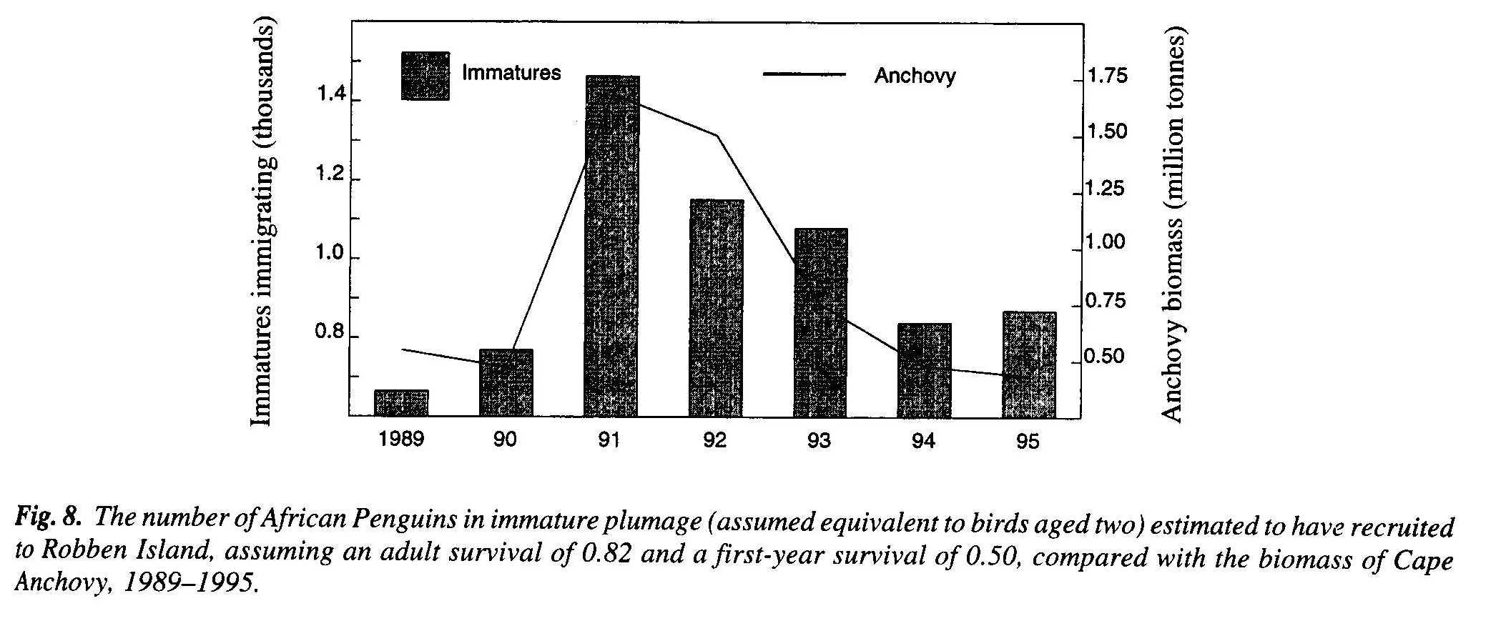
Initial growth of colonies at Boulders and Stony Point must also have been largely attributable to immigration.

P2 Undercounting of juvenile moulters compared to adults

Based on plate 26 of Cooper (1978 International Zoo Yearbook 18:2327) and assuming moulting immature penguins are difficult to distinguish from adults for the last two days of the feather-shedding stage of moult (which lasts about 12.7 days), immature birds could be undercounted by 15% (= ca. 2/12.7) relative to adults.

P3 Standard deviation of time-variable effect relating to detection of juvenile moulters

Immature birds will not necessarily moult at their natal colony – see Whittington et al. (2005. Patterns of movement of the African penguin in South Africa and Namibia. African Journal of Marine Science 27: 215–229).

P4 Variable age at first reproduction

Youngest 3 years and up to 6 years based on the following.

Mean age of first breeding for cohorts banded between 1990 and 1995 was 6 years at Mercury Island and 5 years at Ichaboe, Dassen, Robben and Bird (Algoa Bay) islands (Whittington et al. 2005). At Robben Island, during 1988–1995, of 53 known-age birds, one bred unsuccessfully for the first time at age ca. 2 years, four (outcome unknown) when aged 2–3 years, 12 when 3–4 years, 24 when 4–5 years and 12 when 5–6 years (Crawford et al. 1999). At St Croix Island, of nine birds whose ages at first breeding were known, three were aged 3–4 years, three were 4–5 years and three were 5–6 years (Randall 1983).

P5 Maximum number of fledglings per pair per year

Based on possible fledging of two broods per year and a maximum average production per breeding attempt of about 0.9 chicks (see below) the maximum number of fledglings per pair per year would be about 1.8 (that would be wonderfully good).

In Namibia from 1996–2004, an average of 0.61 chicks fledged per breeding attempt (Kemper et al. 2007e). Averages of 0.70 chicks were fledged per breeding attempt at Mercury Island (SD = 0.80, n = 674 monitored attempts) and 0.61 chicks at Ichaboe Island (SD = 0.80, n = 1240) from 1996–2004; averages of 0.44 chicks were fledged at Halifax Island (SD = 0.74, n = 571) from 2000–2004 and 0.71 chicks at Possession Island (0.87, n = 295) from 1999–2004 (Kemper et al. 2007e). At Marcus and Jutten islands, chicks fledged per nest increased from ca. 0.15 in 1984 to 0.55 in 1989, breeding success being significantly related to the biomass of sardine (Adams et al. 1992). At Dassen Island, pairs fledged 0.37–0.67 chicks p.a. (Frost et al. 1976b). From 1994–2000, an average of 0.89 chicks were fledged per breeding attempt, with breeding success significantly related to the combined biomass of anchovy and sardine (Wolfaardt et al. 2008b). At Robben Island during 1989–1995, pairs fledged 0.32–0.59 chicks per year (Crawford et al. 1999); in 1996 0.65 chicks; in 1998 0.60 chicks (Crawford et al. 2000b). From 1989–2004, when biomass of anchovy and sardine < 2 million tonnes, 0.46 chicks per year were fledged and 0.73 chicks per year, when biomass > 2 million tonnes. Breeding success was significantly related to the combined biomass of these two prey species (Crawford et al. 2006a). Pairs fledged 0.61 and 0.38 chicks per year at Boulders (in 1998) and at St Croix Island respectively (Randall 1983, Crawford et al. 2000b).

Other: Adult survival

Up to an average of 0.91 per annum would be good based on the following. It may occasionally be higher.

Annual adult survival varied from 0.60–0.86 in Namibia between 1994 and 2003, mean 0.78 (Kemper 2006). During 1987–1998 for both Dassen and Robben islands, it was 0.81 (Whittington 2002). At Robben Island, it ranged between 0.82 and 0.89 in 1993/94 (Crawford et al. 1999). It fell below 0.60 at Dassen Island from 2005 to 2007 and at Robben Island in 2007, being just 0.46 at Robben Island in 2007 (Altwegg 2009). At Dyer Island, it was 0.69 from 1979–1985 (La Cock & Hänel 1987). At St Croix Island, annual adult survival averaged 0.91 from 1976/77–1981/82 (Randall 1983).

