2007 International Stock Assessment Workshop recommendations relating to west coast rock lobster data and operating models
S.J. Johnston

Each recommendation below was ranked High (H), Medium (M) or Low (L) by the Workshop participants based on the importance of the recommendation in terms of its likely impact on management decisions. Comments on the progress made for each recommendation is provided in italics.

D. West and South Coast rock lobster
D.1 (H). The basis for developing standardized catch-rate indices should be revisited starting with model selection. During this exercise, it is necessary to: a) compare the standardised and nominal catch-rate series and determine which factors cause the standardized catch-rate indices to differ from the nominal catch-rate series, and b) examine all of the standard regression diagnostics (e.g. standardised residuals versus predicted values; q-q plots; residual trends with time).
The models and methods used for catch-rate standardisation were selected by the MCM Rock Lobster Working Group several years ago and it is now appropriate to revisit these given new information and techniques. Consideration should be given to treating the logarithm of catch as the dependent variable if measures of effort are to be included in the catch-effort standardisation. In addition, the number of years that each vessel has used GPS and plotters should be considered as a factor if the relevant data area available.
Comment: Stepwise regressions were applied to obtain area- and method- (traps or hoopnets) specific models for CPUE standardisation and standard regression diagnostics were examined. The logarithm of catch has not yet been considered as a dependent variable because of time constraints, and no information has yet become available regarding GPS and plotter introduction. If the industry were able to provide information on when these two navigational aides were installed, then these could be considered as factors in the GLM.

D.2 (H). Convene a meeting of local experts to discuss the logistical considerations (including issues related to education, type of traps, etc.) related to implementing an at-sea programme to collect length-frequency information.
This is an additional data source that would enhance the assessment of South and West Coast rock lobster. It is possible that an at-sea sampling programme could augment the currently shore-base sampling programme.
Comment: It would appear no further progress has been made on this issue.

D.3 (H). Continue discussion on the best way to expand data recorded in logbooks.
The effort to improve data collection to cover the full range of relevant data (operational and environmental) should be continued. A pilot project of expanded logbook collection on 10 West Coast rock lobster vessels was implemented early this year (2007). This effort should be expanded to more vessels and other fisheries. Catch data should include: location (at a level sufficient to determine depth), soak time, and the catch in number (in addition to that in mass).
Comment: progress unknown.

E. West Coast Rock Lobster
E.4 (H) There is an urgent need to improve the precision of the current CPUE and FIMS indices of abundance for the West Coast rock lobster resource so that TACs might be set in a manner that responds to resource trends more closely.
Approaches which should be considered in this regard include: (a) improving the CPUE indices by collecting the data on a finer scale as well as relevant environmental data (e.g. oxygen levels) at catch sites; and (b) improving the FIMS indices by reducing the intensity of sampling on each of the two current legs in each area to allow the number of legs to be increased (to better average over spatially-correlated catchability variations), and by collecting environmental data (e.g. oxygen levels) at catch sites. The improvement of the FIMS programme could be facilitated by a workshop of scientist and other stakeholders.
Comment RE a):. Preliminary work by Jean Glazer indicated that the sample sizes per sub-area are fairly patchy for most areas and would make GLM analyses at such a level impossible, though perhaps subdivision at a more aggregated scale might be considered.
Comment RE b): This has been looked at by Anabela Brandao and Danie van Zyl (see MCM/2010/FEB/SWG-WCRL/01).

E.5 (H). Continue to use a spatially-structured operating model for west coast rock lobster
At the December 2005 Workshop, the Panel recommended that a spatially disaggregated operating model be used for evaluating candidate OMPs for the West Coast fishery. This approach remains appropriate because there are clear spatial differences in the dynamics of the resource, and the present Workshop endorsed continued use of a spatially-structured model for West Coast rock lobster.
Comment: The WCRL operating models continue to be based on spatially-structured models.
E.6 (H). Modify the areas used when calculating the FIMS indices of abundance so that these include all of the area within the relevant strata.
The areas currently used when calculating the FIMS index of abundance exclude areas in MPAs and that north of the Olifants Rover. However, the biomass in the assessment pertains to the entire resource so that these additional areas need to be taken into account.
Comment: This has been dealt with in the updated FIMS analyses.

E.7 (H). Conduct a systematic evaluation of the factors which lead to reductions in estimates of recruitment prior to 1970 for the RC1 model.
The standard RC1 assessment model results imply a large decline in recruitment before 1970. It is important to understand the reasons for this. The factors that should be considered in the investigation include: a) the early length frequencies (ignore the earliest length frequencies in this sequence), b) levels and trends in somatic growth, and c) the survival rates for males
Comment: This has yet to be examined in detail.

E.8 (M). The implications of a possible reversal of the trend of eastwards movement of rock lobsters for the standardisation for CPUE indices for Area 8 for input to assessment models and OMP computations needs consideration by the MCM Rock Lobster Working Group.
Reports of declining CPUEs east of Cape Hangklip may reflect the start of a reversal of the trend of eastward movement of rock lobsters over the last 1-2 decades.
Comment: Document MCM/2010/AUG/SWG-WCRL/10 shows a decline in CPUE EOH since around 2001. Also a deep water survey has been completed in the area East of Hangklip – no lobsters were caught in the deep in this area during the three completed surveys (van Zyl, pers. commn). Should we be revising the area extension factors that have been applied to Area 8 since the expansion started?
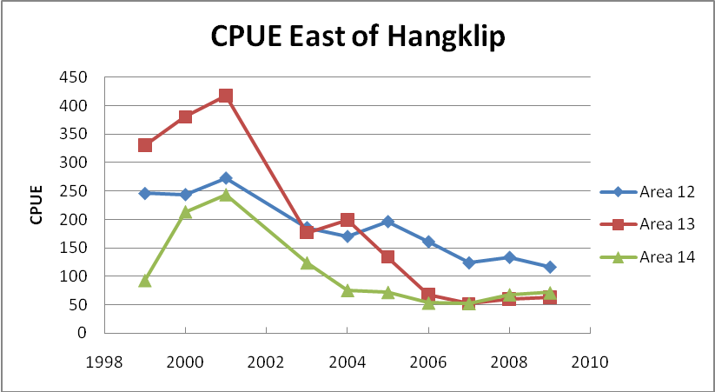

E.10 (M) The assessment should examine the sensitivity of the results to alternative assumptions regarding the magnitude and spatial split of the historical catches.
If the assessment is to be spatially-structured, it is necessary to disaggregate the historical catches spatially. However, there is considerable uncertainty regarding both the magnitude and spatial distribution of the historical catches, and it is clear that the pattern of catches today is very different from that in the past.
Comment: This has yet to be done.

E.11 (M). The sensitivity of the results of assessments to ignoring the data on somatic growth for the years for which the data set is small should be examined.
The tag-recapture sample sizes for some years are small (particularly when the data set is pruned to capture a “moult window”), which results in estimates of somatic growth for those years that are very imprecise. The implications of exclusion of data need to be considered by the MCM Rock Lobster Working Group.
Comment: This has been handled by moving to using a moult-probability model which does not require this data pruning.

E.12 (L). Examine the sensitivity of the results to starting the model in recent years.
There is uncertainty about the dynamics of the population in the years prior to the first year for which length-frequency data are available. The robustness of the performance of the OMP to starting the operating model in a recent year (e.g. 1975) should be evaluated. It is necessary to specify a method to determine the initial abundance and length-structure of the population in the first year considered in the model for a complete specification.
Comment: This has yet to be done.

E.13 (L). Plot the time-sequence of selectivity-at-length patterns
Selectivity-at-length changes over time, but the documents presented to the December 2005 Workshop did not show the annual selectivity-at-length patterns. These should be plotted and checked for realism.
Comment: This has been done for the recently updated assessments (see Figure 1 of Fisheries/2010/Sep/SWG-WCRL/23) and will be reproduced for the 2010 Workshop.

