Implications of the Impacts on CPUE as a Result of the Introduction of MPAs on Hake OMP Performance

Rebecca A Rademeyer and Doug S Butterworth
November 2010

Abstract
The possible effects of the introduction of MPAs on hake CPUE, and hence on the performance of the hake OMP, is examined for a number of scenarios. The impact is modeled as a change in catchability q whose existence and magnitude is unknown to the manager. Retuning the OMP to adjust for this could necessitate lowering annual TACs for the next five years by some 15-20 thousand tons to maintain the same levels of risk for the M. paradoxus population. Naturally this magnitude depends on the size of the change in q assumed (here some 20%).

Introduction
The introduction of MPAs (of a large scale and in areas of high fishing activity) is known to cause changes in fishing behavior, such as vessels clustering at MPA boundaries, and hence to impact CPUE. This is of importance for the hake OMP, which depends heavily on the input of CPUE data which are assumed to reflect abundance trends accurately. Indeed the new hake OMP incorporates a heavier relative weighting of CPUE data compared to research survey data than in the past, given the lesser variance displayed by CPUE data.
If the relationship between hake CPUE and abundance is changed by the introduction of MPAs in offshore waters, this will impact the performance to be anticipated under the OMP. Indeed the OMP should be retuned to reflect the same resource “risk” as under the current situation.
The key question then is how might CPUE change, so that the OMP could be adjusted to compensate, and what would be the impact on anticipated performance? In the USA, the approach is simple: on introduction of MPAs, CPUE data are no longer considered reliable indicators of abundance trends and so are no longer used in calculating advice for management (A. Punt, pers. commn). This scenario is examined below for hake in the context of a final candidate for the new hake OMP, together with some other scenarios which maintain the use of CPUE data in the OMP, but without knowledge of whether and to what extent the MPA introduction has modified the CPUE. This modification is taken here to be representable by a change in the value of the catchability coefficient q.

Approach and Results
Table 1 shows the implications of applying a central new hake OMP candidate (CMPf1b) if the comparability of CPUE data is compromised in various ways (whose magnitude or direction would not be known in practice) through the (immediate) introduction of MPAs. The specific possibilities examined are:
- Rob33a: no future CPUE data accepted for OMP input.
- Rob33b: new CPUE with prior on q: For each 20-year simulation, the change in lnq is drawn from N(0;0.1²): where from
- Rob33c: new CPUE with lower q:
- Rob33d: new CPUE with higher q:
The last three possibilities consider a change in q that could be anywhere in a wide range summarized by a CV of about 10%, or fixed changes in q of about 20% either up or down. Clearly the size assumed for any change affects the results to follow, so that these sizes need to be realistic. The CV and change values assumed would not seem implausible, given that annual hake CPUE values show a CV about underlying trends of some 15%-25%, so that changes of these magnitudes would also not be immediately apparent in the new data forthcoming after MPA introduction.
Note that since the fact that q has changed is not known, this is not known either to the OMP in place.
Results are also shown for when the OMP is retuned to the same risk level as for RSa under CMPf1b, where the "risk level" is first taken as M. paradoxus B^{sp}_{low}/B^{sp}₂₀₁₀ (i.e. 0.72) and then as M. paradoxus B^{sp}₂₀₃₀/B^{sp}₂₀₁₀ (i.e. 1.27), both pertaining to lower 2.5%iles.
Figs 1-3 compare the median catch trajectories, the lower 2.5%ile spawning biomass envelopes for M. paradoxus spawning biomass relative to its 2010 level and to MSYL.

Discussion
Results for the four MPA-introduction possibilities, with no retuning of CMPf1b, are pretty much as expected when compared to those under the RS: catches drop if q decreases (Rob33c), but increase appreciably if q increases (Rob33d), and in this case to such an extent that the risk of high depletion of the M. paradoxus stock is substantially increased (see Table 1 and Fig. 1).
The first set of retunings considered – to the same “low para” statistic (lower 2.5%ile for the lowest spawning biomass compared to 2010) as under the RS - produce some perhaps unexpected results, in that the median average TAC for the next ten years is little changed (Table 1). However, on closer inspection (see Fig.2) some problems are evident. First in a risk context, though initially the lower 2.5%ile for the spawning biomass probability interval envelope increases similarly to that for the RS, , after about 8 years the continued improvement that is seen for the RS ceases (except for Rob33a where CPUE data are disregarded). Such continued improvement is a feature of the M. paradoxus recovery strategy which has been a component of the motivation for continued MSC certification for the hake trawl fishery. Secondly, apart from the no CPUE case for which median catches first increase rapidly and then decrease again, median catches stay near unchanged for about 5 years, and then increase rapidly to much higher levels than for the RS, i.e. the TAC does not change as smoothly over time as for the RS.
Risk comparability with the RS in this sense can be achieved by tuning instead to the same “low para” value in 2030. The results are shown in Fig. 3 and evidence an appreciable immediate fall in TAC for all scenarios except for the no CPUE case (Rob33a). Results for TACs in Table 1 show a decrease in median average TAC for the next decade in about the 5-10% range, though this reduction is rather more severe over the first five years. The no CPUE case is again an exception, with TAC trends almost the reverse of those for the other three scenarios.

Conclusion
The broad indications of this initial analysis are that the introduction of MPAs and consequent OMP retuning to adjust for a possible impact on catchability for CPUE series could necessitate annual hake TACs which are some 15-20 thousand tons lower than would otherwise be the case for the next five years to maintain the same risk levels for the M. paradoxus stock. Naturally this magnitude depends on the size of the change in q assumed (here some 20%).

Table 1: Projections results (either median or lower 2.5%ile) for a series of performance statistics for the RS and the four robustness tests under CMPf1b, CMPf1b tuned to M. paradoxus B^{sp}_{low}/B^{sp}₂₀₁₀ and CMPf1b tuned to M. paradoxus B^{sp}₂₀₃₀/B^{sp}₂₀₁₀. Catch units are thousand tons.
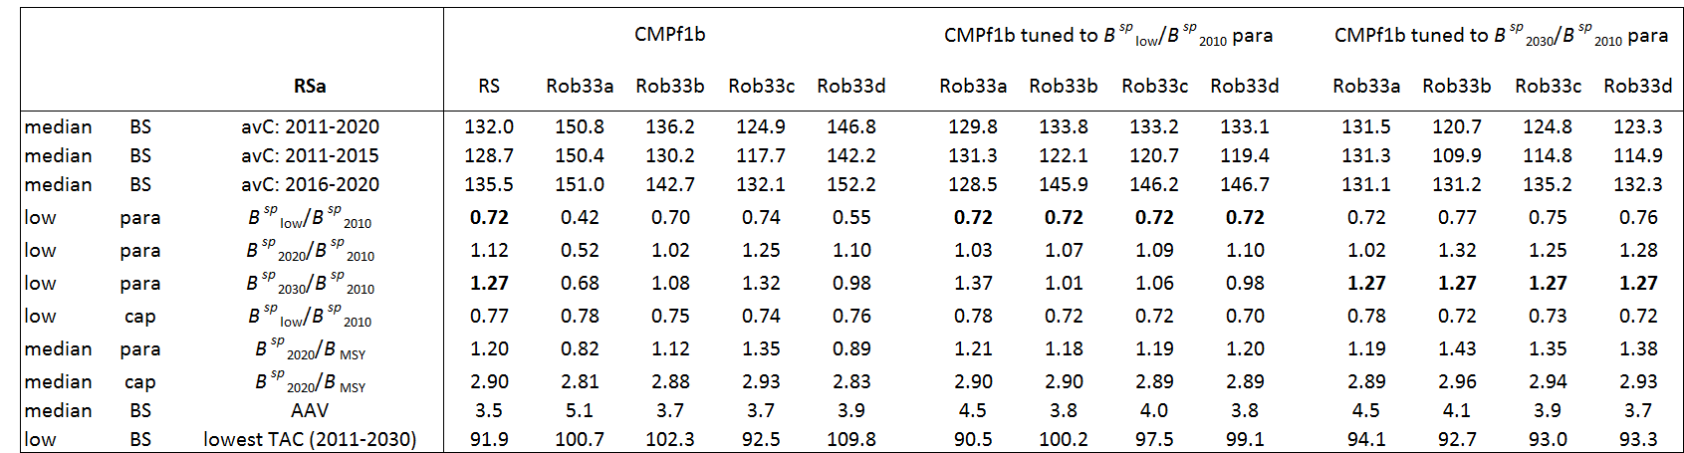

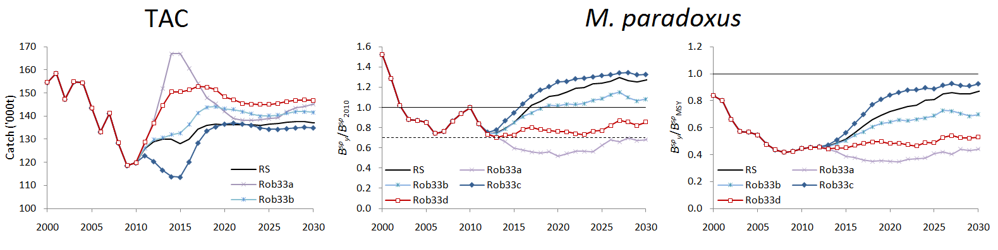

Fig. 1: Median catch trajectories, and lower 2.5%-ile M. paradoxus female B^{sp}_{y}/B^{sp}₂₀₁₀ an B^{sp}_{y}/B^{sp}_{MSY} envelopes for the RS and the four robustness tests under CMPf1b.
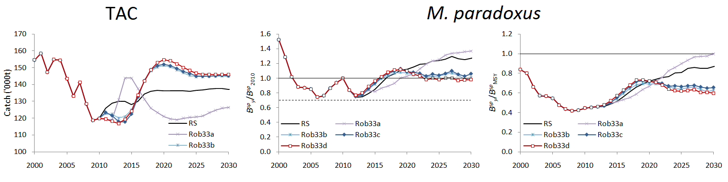

Fig. 2: Median catch trajectories, and lower 2.5%-ile M. paradoxus female B^{sp}_{y}/B^{sp}₂₀₁₀ and B^{sp}_{y}/B^{sp}_{MSY} envelopes for the RS and the four robustness tests tuned to the same B^{sp}_{low}/B^{sp}₂₀₁₀ M. paradoxus as that for the RS.
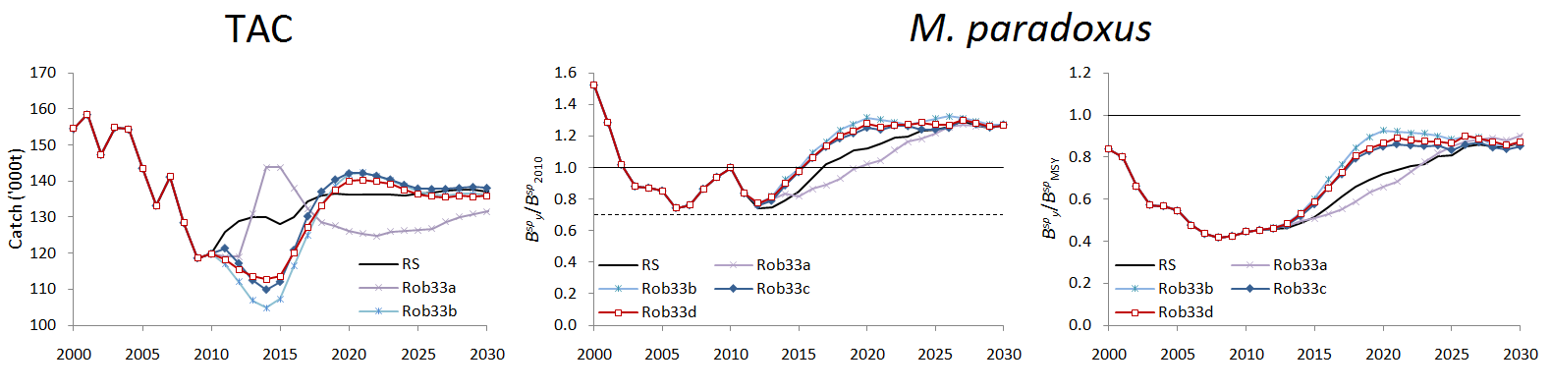

Fig. 3: Median catch trajectories, and lower 2.5%-ile M. paradoxus female B^{sp}_{y}/B^{sp}₂₀₁₀ and B^{sp}_{y}/B^{sp}_{MSY} envelopes for the RS and the four robustness tests tuned to the same B^{sp}₂₀₃₀/B^{sp}₂₀₁₀ M. paradoxus as that for the RS.

