**Conditioning of the full set of robustness tests for the South African hake resource to be used in OMP-2010 testing and constant catch projections**

Rebecca A Rademeyer and Doug S Butterworth

June 2010

**INTRODUCTION**

Results for conditioning of the full set of robustness/sensitivity tests for the current hake OMP revision process are given, and projections carried out under a constant catch strategy.

Although the final one or two CMPs will be checked on the complete suite of robustness tests, only a selected subset of robustness tests will be used to test the CMPs routinely. The intention is therefore to reduce the number of robustness tests that will be run routinely on the CMPs by selecting the ones which appear under constant catch projections to present the greatest challenges from a resource conservation perspective. (Naturally constant catch projections do not provide discrimination amongst tests that involve changes to default assumptions for aspects of future data such as changes in precision, so that such tests will remain retained in this selected set.) A projected constant catch of 150 000t has been chosen as this will be more informative (in terms of the poor resource conservation performers) than a constant catch set at the current TAC.

**RESULTS**

*Tests related to M. paradoxus*

Table 1 summarises the full set of robustness/sensitivity tests considered. (Some of these tests should be considered as “sensitivities” rather than formal robustness tests to provide OMs for candidate OMP testing, because they are included more to indicate impacts of specification variation on results than as arguably alternative plausible representations of reality.) While Rob1 to Rob29 involve different assumptions about the resource dynamics or past data, it is only in the projections that Rob30 to Rob38 change from the Reference Case (RS1).

Table 2 summarises the key management quantities for Rob1 to Rob29, while Table 3 compares their different contributions to the total negative log-likelihood. Results for Rob1 to Rob16 have been presented earlier in Rademeyer and Butterworth (2010); however, an error was found in Rob10 and in some cases a better minimum was found (-lnL in bold in Table 2) so that these revised results are given here.

Fig. 1 plots the estimated spawning biomass trajectories for these tests.

Three performance statistics (, and  for the female component of the population) are plotted in Fig. 2 for the full set of RS and robustness tests under a constant catch of 150 000t.

It is suggested that the following robustness tests related to *M. paradoxus* be retained in the selected set at this stage:

*Changes in the past*: robustness tests Rob5 (true Ricker), Rob13 (decrease in *K*), Rob17 (start in 1978) and Rob25 (lower steepness *h*).

*Changes in the future*: robustness tests 31f (case of no surveys and an undetected catchability trend for CPUE), Rob35 (undetected catchability trend for CPUE) and Rob37 (decrease in *K*).

With the exception of tests Rob31 and Rob35 for which constant catch trials do not provide a test of the issue involved, the reason for these selections is inadequate increase of spawning biomass towards its MSY level.

*Tests related to M. capensis*

The robustness tests described in Table 1 are mostly based on RS1, i.e. they are representative of RSa, for which *M. capensis* is currently well above MSYL. Robustness tests are also needed in the case when the extent of *M. capensis* depletion is estimated to be relatively high (RSb) and six robustness tests have been selected to be run on RS11 (one of the RSb OMs). For changes in the past, three of the four robustness tests selected for *M. paradoxus* testing above have been chosen (Rob5, Rob13 and Rob25, but not Rob17 which is of a different nature and does not show *M. capensis* to be heavily depleted) and for changes in the future, Rob37 (decrease in *K*) has been selected.

Table 4 summarises the key management quantities for the four tests based on RS11, while Table 5 compares their different contributions to the total negative log-likelihood. Fig. 3 plots the estimated spawning biomass trajectories for these tests.

Three performance statistics (, and  for the female component of the population) are plotted in Fig. 4 for RS11 and these four robustness tests under a constant catch of 150 000t.

It is suggested that these four robustness tests related to *M. capensis* be retained in the selected set at this stage.

**REFERENCES**

Gaylard JD and Bergh MO. 2009. Update of the hake species split models in the light of more recent survey data and a revision of the large/medium/small size classification. Unpublished report. MARAM IWS/DEC09/HP/14.

Glazer JP and Butterworth DS. 2009. Results from sensitivity tests related to the models used to standardize the offshore commercial trawl CPUE data of *M. capensis* and *M. paradoxus* respectively. Unpublished report, Marine and Coastal Management. MCM/2009/NOV/SWG-DEM/95.

Rademeyer RA and Butterworth DS. 2010. Proposed Reference Set for the South African hake resource to be used in OMP-2010 testing. Unpublished report, Marine and Coastal Management, South Africa. MCM/2010/FEB/SWG-DEM/05.

Wilhelm M, Durholtz D and Roux J-P. 2009. Age validation and methods of age determination of hake – based on age validation of Namibian *Merluccius capensis*. Unpublished report, Marine and Coastal Management. MCM/2009/JULY/SWG-DEM/58.

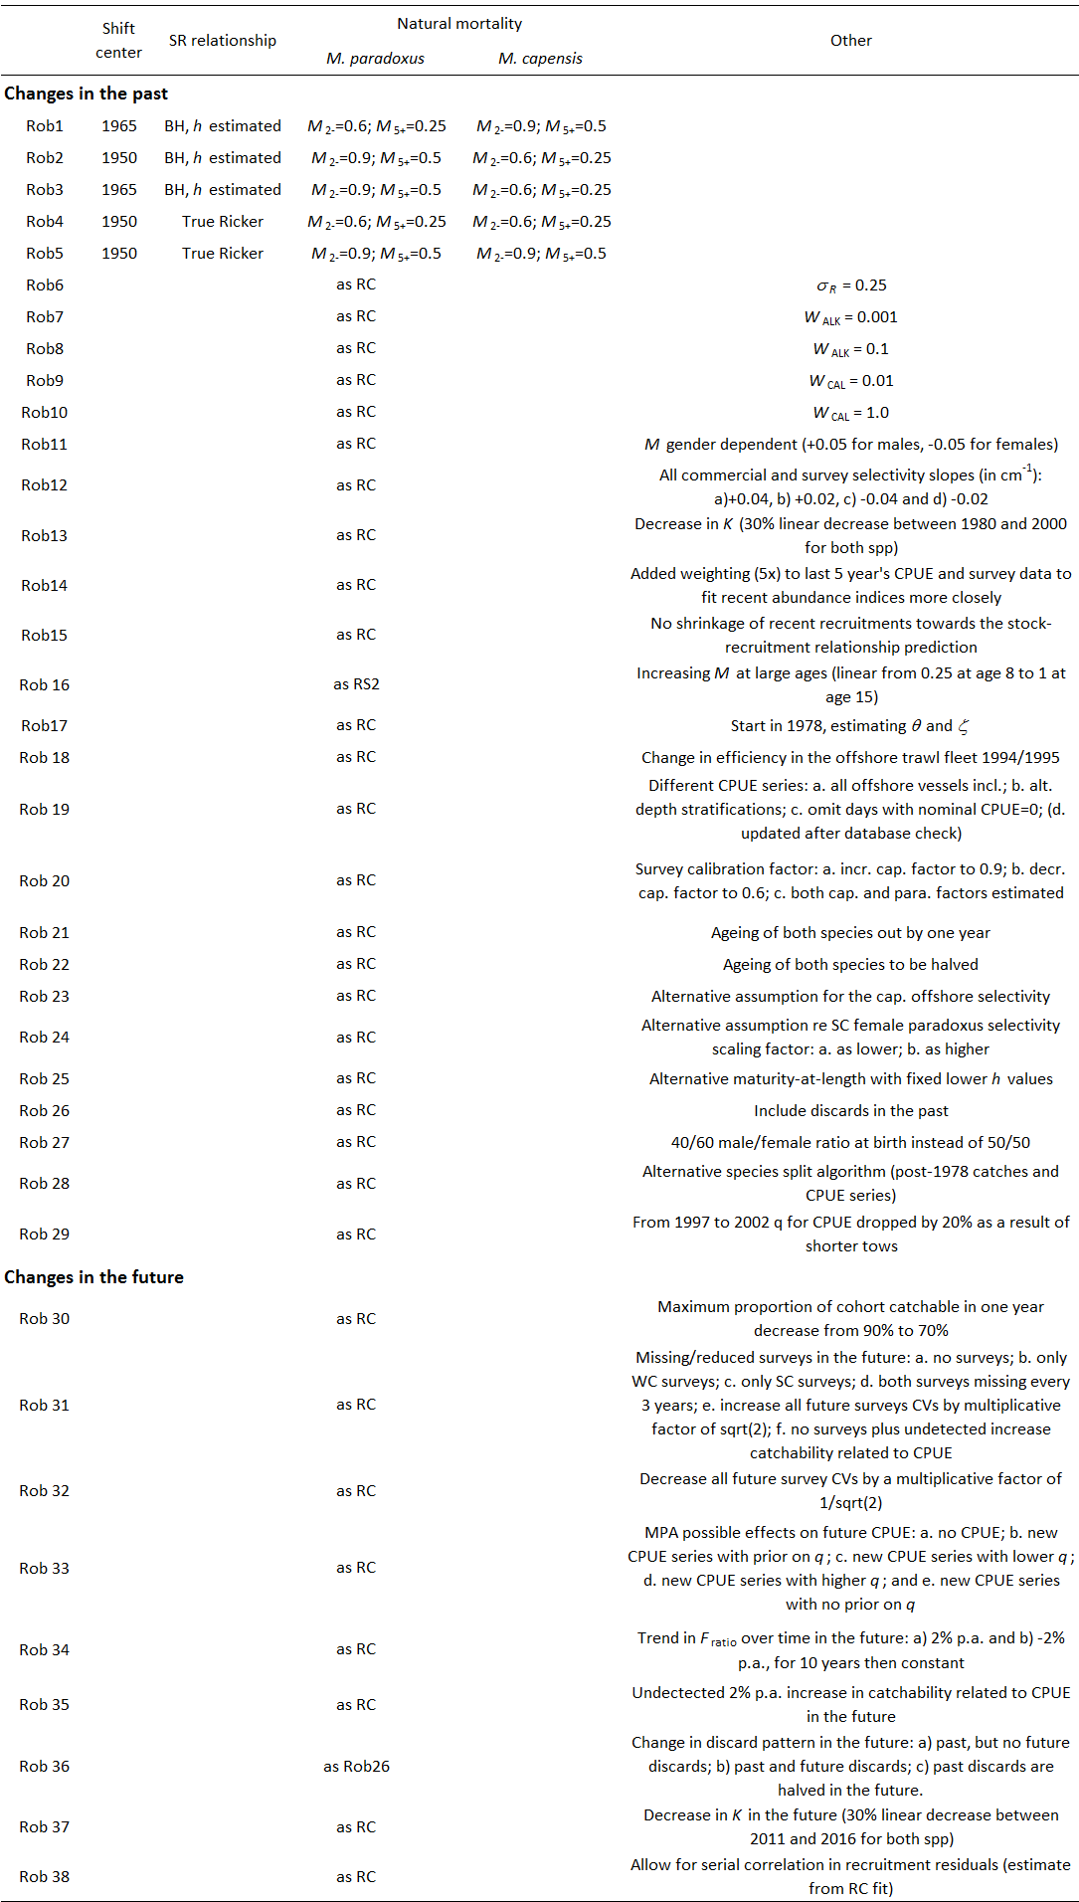Table 1: Summary of the full set of robustness/sensitivity tests.

Table 2: Estimates of management quantities for RS1 and Rob1 to Rob29. -lnL values in bold highlight cases where a better minimum was found than reported in Rademeyer and Butterworth (2010).  and  are for both genders combined, while  and  are in terms of the female only spawning biomass.

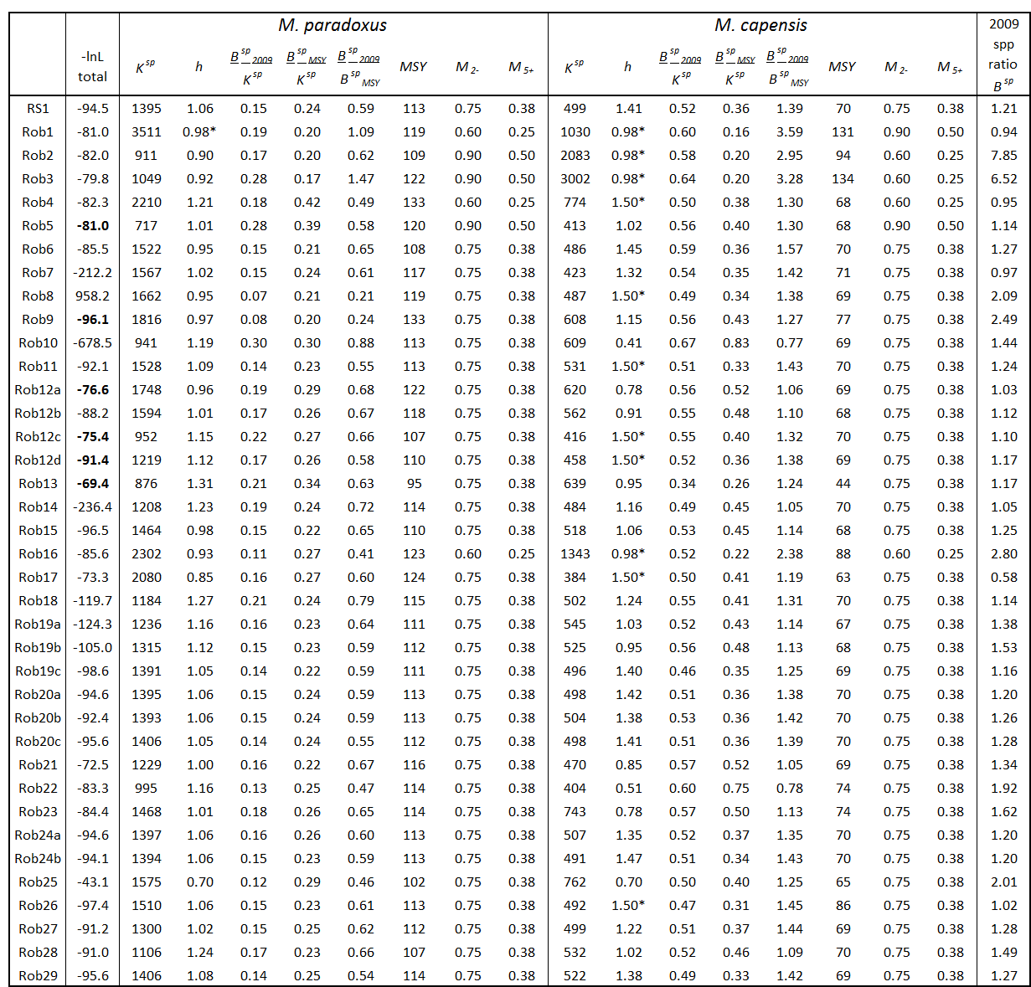

Table 3: For each contribution to the total negative log-likelihood (-lnL), differences in -lnL compared to the Reference Case (RS1).

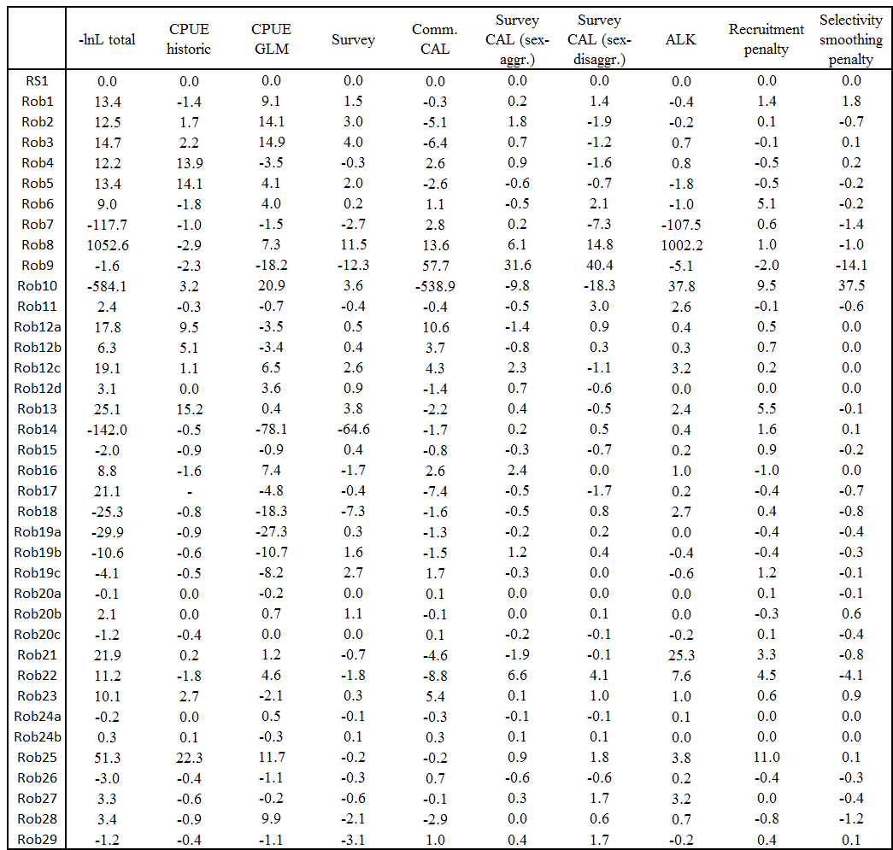

Table 4: Estimates of management quantities for RS11 and three robustness tests based on this OM.  and  are for both genders combined, while  and  are in terms of the female only spawning biomass.

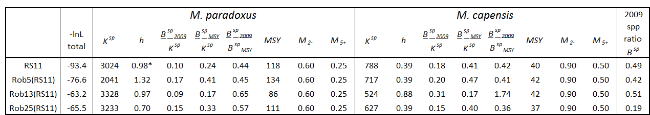

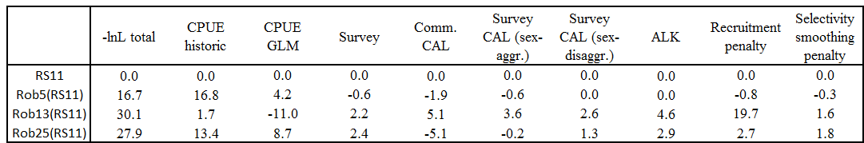Table 5: For each contribution to the total negative log-likelihood (-lnL), differences in -lnL compared to RS11.

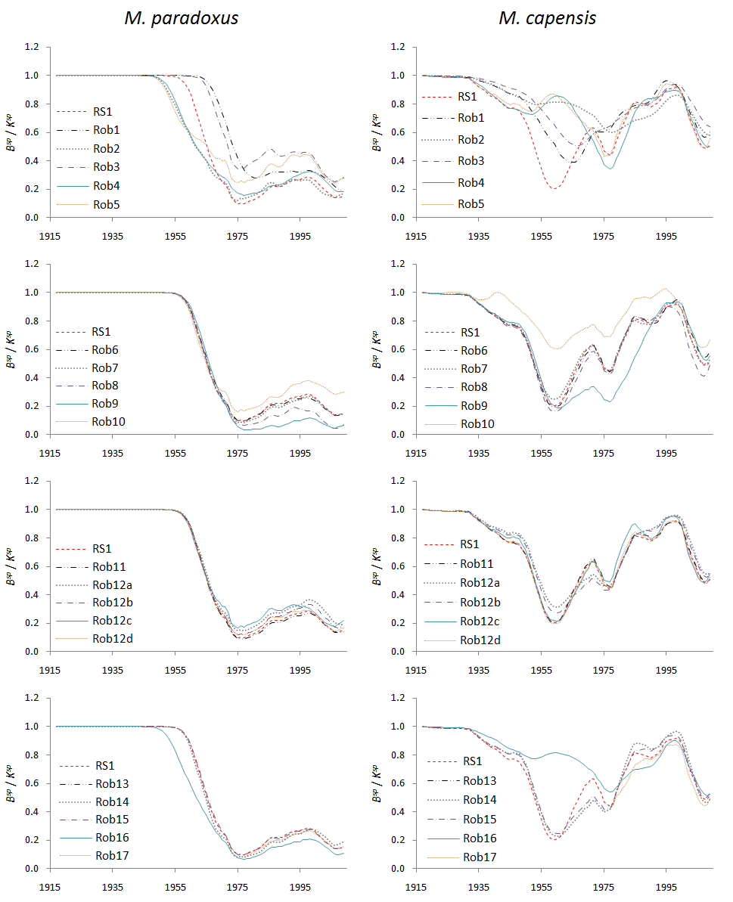

Fig. 1: Estimated gender-aggregated spawning biomass trajectories for *M. paradoxus* and *M. capensis*, relative to pre-exploitation levels, for the RC (RS1) and robustness tests Rob1-Rob29.

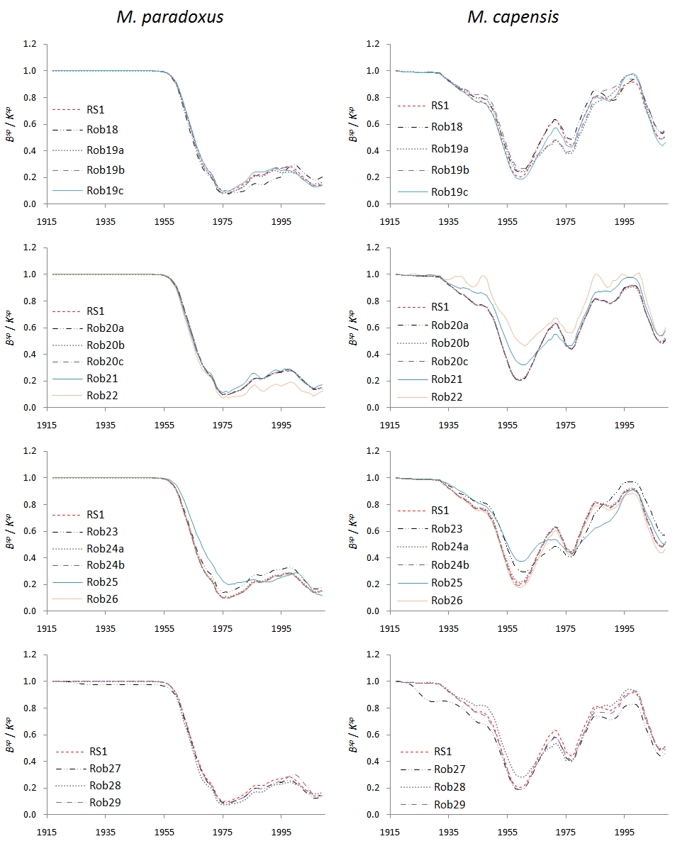

Fig. 1: continued

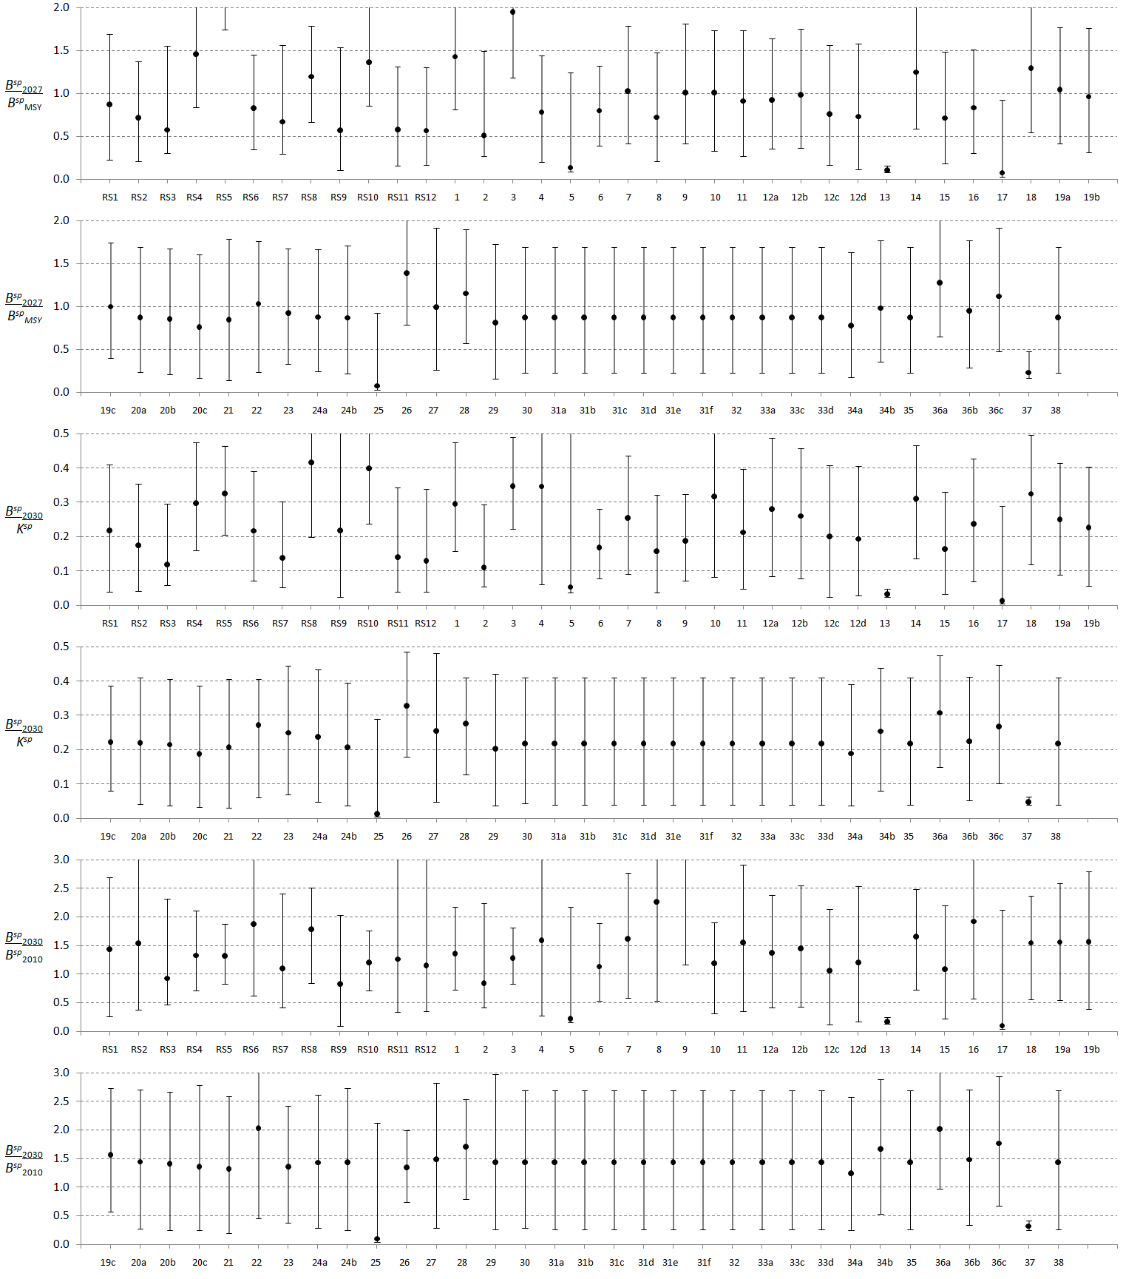

Fig. 2a: Three performance statistics (, and , in terms of female biomass only) for ***M. paradoxus*** for the full set of RS and robustness tests under a projected constant catch of **150 000t**. In some instance, the statistics are outside the area covered by the plot.

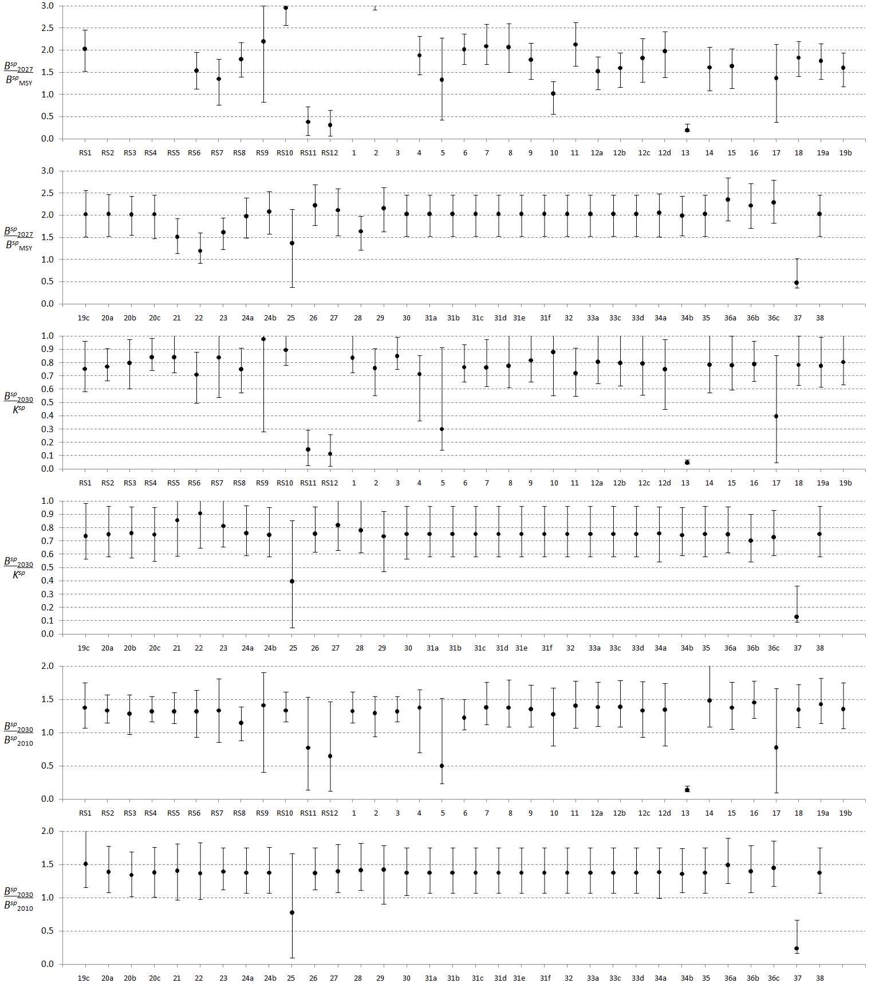

Fig. 2b: Three performance statistics (, and , in terms of female biomass only) for ***M. capensis*** for the full set of RS and robustness tests under a projected constant catch of **150 000t**. In some instance, the statistics are outside the area covered by the plot.

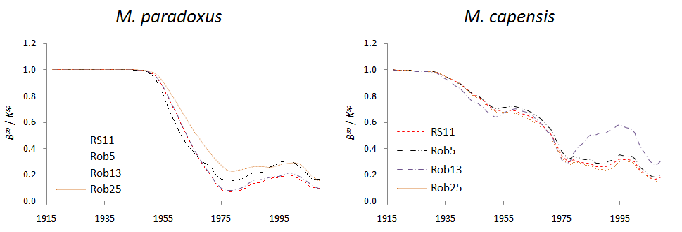

Fig. 3: Estimated gender-aggregated spawning biomass trajectories for *M. paradoxus* and *M. capensis*, relative to pre-exploitation levels, for the RS11 and three robustness tests based on this OM.

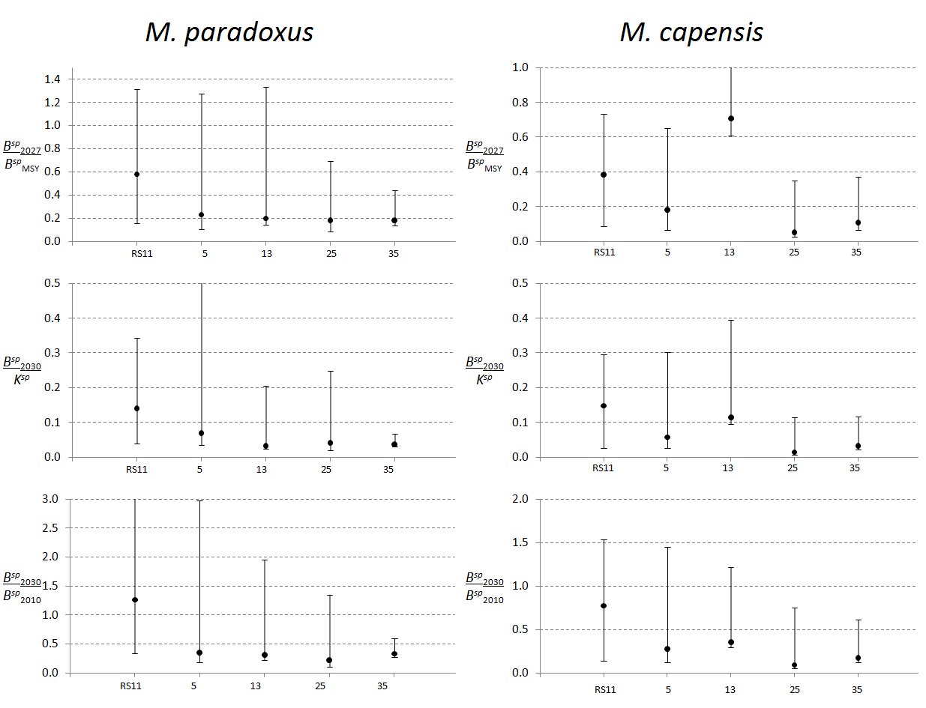

Fig. 4: Three performance statistics (, and , in terms of female biomass only) for *M. paradoxus* and *M. capensis* for RS11 and four robustness tests based on this OM under a projected constant catch of **150 000t**.