**An extension to the simple implementation of the “River Model” to estimate the impact of fishing on the amount of anchovy available to West Coast penguin colonies which takes account of within season variability in recruitment**

**D.S. Butterworth* and C.L. de Moor[1]\***

*Correspondence email:* [*doug.butterworth@uct.ac.za*](mailto:doug.butterworth@uct.ac.za)

**Abstract**

The assumption of an earlier analysis of a constant flow of anchovy recruits along the West Coast during the winter months is replaced by introducing variability at a monthly scale. The extent of this variability is based on the monthly variability of anchovy catches, and the correlation of this variability with a series of hydroacoustic biomass surveys that took place around Robben Island during the winter months of 2009. The results are qualitatively unchanged from those obtained from the model before the addition of these stochastic elements: fishing decreased the density of anchovy that would otherwise have been available to penguins by appreciably less after 2000 than before. The introduction of stochasticity increases the extent of this reduction since 2000 from at most about 10% to at most about 20%.

**Introduction**

The availability of anchovy to both the purse-seine fishery and predators off the West Coast each year is dominated by the southward “run” of anchovy recruits of the year down the coast originating from areas to the south of the Orange River. The run is typically at its height over the April to September period. An initial very simple implementation of the “river model” assumed that anchovy recruitment consists of six successive packets of equal size, each remaining within the vicinity of the West Coast islands for a duration of 1 month. That implementation showed that over the past decade the reduction of the amount of anchovy recruits available to penguin colonies off the West Coast due to fishing has been at most 10% (Butterworth and de Moor 2010).

In this document this river model is extended to take account of variability in the proportion of the annual recruitment forming the monthly packet. As before, pulse fishing in the middle of each month is assumed. The model is now conditioned on observed catch by month and year.

**Data**

The data used as input to the model are as follows:

1)  - model predicted anchovy recruitment in November of year , in billions (from the assessment of de Moor and Butterworth 2009, listed in Table 1);

2)  - anchovy catch north of Cape Point during the months, *m*, between April and September of year , in thousands of tons (this catch is dominated by the recruits of the year);

3)  - the average anchovy weight at age , in grams; and

4)  - the rate of natural mortality for juvenile (0-year-old) anchovy in the assessment of de Moor and Butterworth (2009), in years-1.

The average weight at age was calculated using a linear interpolation between the average catch weight at age 0 (assumed to correspond to an age of 0.5 years, or 6 months) of 4.86g and the average weight at age 1 in the November survey of 9.72g. This gives a weight at age 7 months of 5.67g and a weight at age 8 months of 6.48g.

**Model**

The assumption is made that the anchovy available to be taken off the West Coast increase from 6 to 7 months of age during the month they are available to the fishery. The proportion of these anchovy fished in this month is calculated by solving the following equation:

 (1)

The anchovy recruitment present in month *m* of the six month winter period considered is now permitted to vary instead of being held fixed and equal to 1/6 as in Butterworth and de Moor (2010). There are two sources of information on the extent of this variability: the variability by month of catch within a season, and the set of six hydroacoustic surveys carried out around Robben Island during the winter of 2009 (which reflect a distribution during that year highly correlated with the monthly pattern of catches – see Appendix A). Thus the proportion each year of recruitment present close to a colony in a particular month is taken to be the proportion of the catch that year taken in that month, modified by a random factor drawn from a distribution of the variation in that proportion over time. This is estimated as follows[2]:

 (2)

where  denotes the estimated proportion of anchovy recruitment from November of year *y*-1 which is in the vicinity of the island during month *m*, and

,

 (3)

where  and 

with  and 

 is the estimated correlation between the monthly proportion of anchovy recruitment present close to a colony and the monthly proportion of anchovy catch. This was calculated based on six surveys carried out around Robben Island in 2009 and the monthly catches that year, and found equal to 0.903 (see Appendix A).  denotes the average catch in month *m* over all years and  denotes the variance in the catch in month *m* over all years.

The biomass entering the West Coast at the start of the fishing month is then:

 (4)

and leaving at the end of the same month is:

 (5)

The density of anchovy as experienced by the penguins is proportional to:

 (6)

The quantity of interest is how much this density was decreased by fishing, i.e. the “reduction”:

 (7)

**Results**

The average monthly fishing proportion (*F)* and reduction (*R*) quantities calculated are listed in Table 2, and the median and approximate 95% PI[3] of *R* over time is plotted in Figure 1. These quantities are also plotted in Figures 2, 3 and 4 for the alternative scenarios where the correlation between the monthly proportion of recruitment close to a colony and the monthly proportion of the catch is respectively assumed to be 0.8, 0.7 and 0.6.

**Discussion**

Earlier non-stochastic analyses (Butterworth and de Moor 2010) suggested that over the last decade (which encompasses the period of a substantial drop in penguin abundance), fishing had decreased the amount of anchovy that would otherwise have been available to the penguins by at most some 10%. Furthermore the extent of this reduction after 2000 was typically rather less than before then. The introduction of stochasticity does not change these results qualitatively. Under the base case estimate of the observation-based correlation of 0.903 between variation of anchovy abundance close to an island and monthly variation of anchovy catches, this post-2000 decrease extends to at most about 20% (Figure 1). Even if one takes that correlation to be appreciably less (Figures 2, 3 and 4) that extent does not increase greatly.

This inference could be biased if much of the anchovy recruitment passed by well offshore, where it is not available to either the fishery or to the penguins. However Janet Coetzee and Dagmar Merkle have kindly provided distribution plots from the annual recruitment surveys (Appendix B) which show most anchovy off the West Coast to occur within about 25 to 30 n. miles from the shore, in close proximity to the penguin breading colonies, and almost all anchovy is caught within that same distance of the coast (van der Westhuizen pers. comm.). As breeding penguins can forage to such distances, this potential bias would not appear to be substantial.

**Acknowledgements**

Janet Coetzee and Dagmar Merkle are thanked for providing data for input to this model.

**References**

Butterworth, D.S., and de Moor, C.L. 2010. A Very Simple Implementation of the “River Model” to Estimate the Impact of Fishing on the Amount of Anchovy Available to West Coast Penguin Colonies. MCM Document MCM/2010/SWG-PEL/Island Closure Task Team/10. 4pp.

Coetzee, J., Merkle, D., Shabangu, F., and Rademan, J. 2010. Updates and corrections to inshore survey biomass estimates. MCM Document MCM/2010/SWG-PEL/05. 5pp

de Moor, C.L., and Butterworth, D.S. 2009. Updated Anchovy Assessment. MCM Document MCM/2009/SWG-PEL/31. 10pp

**Table 1.** The annual numbers of anchovy recruits (in billions), .

|  |  |
| --- | --- |
| Year |  |
| 1987 | 256.7 |
| 1988 | 208.2 |
| 1989 | 64.2 |
| 1990 | 138.3 |
| 1991 | 384.6 |
| 1992 | 211.1 |
| 1993 | 119.5 |
| 1994 | 61.4 |
| 1995 | 141.5 |
| 1996 | 47.4 |
| 1997 | 151.0 |
| 1998 | 169.7 |
| 1999 | 292.5 |
| 2000 | 846.9 |
| 2001 | 841.6 |
| 2002 | 396.1 |
| 2003 | 360.7 |
| 2004 | 215.1 |
| 2005 | 288.5 |
| 2006 | 169.2 |
| 2007 | 427.3 |
| 2008 | 639.2 |
| 2009 | 450.4 |

**Table 2.** The anchovy catch north of Cape Point by month between April and September (in thousands of tons) from 1987 to 2009, , and the estimated proportion fished, , and “reduction”, .

|  |  |  |  |  |  |  |  |  |  |  |  |  |  |  |  |
| --- | --- | --- | --- | --- | --- | --- | --- | --- | --- | --- | --- | --- | --- | --- | --- |
| Month |  |  |  | Month |  |  |  | Month |  |  |  | Month |  |  |  |
| 1987 | | | | 1990 | | | | 1993 | | | | 1996 | | | |
| 4 | 40.251 | 0.35 | 0.82 | 4 | 35.196 | 0.35 | 0.82 | 4 | 42.640 | 0.53 | 0.72 | 4 | 3.720 | 0.18 | 0.91 |
| 5 | 12.987 | 0.20 | 0.90 | 5 | 35.026 | 0.33 | 0.83 | 5 | 13.698 | 0.35 | 0.82 | 5 | 10.004 | 0.21 | 0.89 |
| 6 | 50.680 | 0.33 | 0.83 | 6 | 59.514 | 0.36 | 0.81 | 6 | 1.181 | 0.06 | 0.97 | 6 | 13.020 | 0.22 | 0.89 |
| 7 | 76.093 | 0.38 | 0.80 | 7 | 0.559 | 0.04 | 0.98 | 7 | 10.822 | 0.33 | 0.83 | 7 | 0.000 | 0.00 | 1.00 |
| 8 | 67.440 | 0.37 | 0.81 | 8 | 0.216 | 0.01 | 0.99 | 8 | 67.137 | 0.55 | 0.71 | 8 | 0.001 | 0.00 | 1.00 |
| 9 | 23.695 | 0.30 | 0.84 | 9 | 0.035 | 0.00 | 1.00 | 9 | 38.213 | 0.53 | 0.73 | 9 | 0.002 | 0.00 | 1.00 |
| 1988 | | | | 1991 | | | | 1994 | | | | 1997 | | | |
| 4 | 3.327 | 0.13 | 0.93 | 4 | 36.416 | 0.11 | 0.94 | 4 | 16.136 | 0.57 | 0.70 | 4 | 0.021 | 0.00 | 1.00 |
| 5 | 39.794 | 0.40 | 0.79 | 5 | 22.409 | 0.09 | 0.95 | 5 | 39.921 | 0.65 | 0.66 | 5 | 1.163 | 0.04 | 0.98 |
| 6 | 72.661 | 0.47 | 0.76 | 6 | 43.803 | 0.11 | 0.95 | 6 | 17.403 | 0.52 | 0.73 | 6 | 0.669 | 0.02 | 0.99 |
| 7 | 60.439 | 0.46 | 0.76 | 7 | 5.928 | 0.06 | 0.97 | 7 | 0.246 | 0.04 | 0.98 | 7 | 17.969 | 0.13 | 0.93 |
| 8 | 69.951 | 0.48 | 0.75 | 8 | 0.872 | 0.02 | 0.99 | 8 | 29.995 | 0.62 | 0.68 | 8 | 10.678 | 0.11 | 0.94 |
| 9 | 38.802 | 0.45 | 0.77 | 9 | 0.018 | 0.00 | 1.00 | 9 | 2.817 | 0.29 | 0.85 | 9 | 20.166 | 0.13 | 0.93 |
| 1989 | | | | 1992 | | | | 1995 | | | | 1998 | | | |
| 4 | 53.762 | 1.02 | 0.47 | 4 | 49.267 | 0.43 | 0.78 | 4 | 21.590 | 0.33 | 0.83 | 4 | 18.314 | 0.20 | 0.89 |
| 5 | 67.128 | 1.02 | 0.47 | 5 | 58.765 | 0.42 | 0.78 | 5 | 12.866 | 0.25 | 0.87 | 5 | 21.366 | 0.20 | 0.90 |
| 6 | 38.897 | 0.88 | 0.54 | 6 | 34.749 | 0.35 | 0.82 | 6 | 33.851 | 0.33 | 0.83 | 6 | 41.932 | 0.22 | 0.88 |
| 7 | 12.584 | 0.63 | 0.67 | 7 | 42.300 | 0.40 | 0.79 | 7 | 32.289 | 0.35 | 0.82 | 7 | 12.241 | 0.17 | 0.91 |
| 8 | 0.000 | 0.00 | 1.00 | 8 | 55.055 | 0.42 | 0.78 | 8 | 38.732 | 0.36 | 0.81 | 8 | 3.702 | 0.10 | 0.95 |
| 9 | 0.000 | 0.00 | 1.00 | 9 | 25.088 | 0.37 | 0.81 | 9 | 1.268 | 0.09 | 0.95 | 9 | 3.603 | 0.12 | 0.94 |

**Table 2 (cont).**

|  |  |  |  |  |  |  |  |  |  |  |  |  |  |  |  |
| --- | --- | --- | --- | --- | --- | --- | --- | --- | --- | --- | --- | --- | --- | --- | --- |
| Month |  |  |  | Month |  |  |  | Month |  |  |  | Month |  |  |  |
| 1999 | | | | 2002 | | | | 2005 | | | | 2008 | | | |
| 4 | 8.349 | 0.12 | 0.94 | 4 | 21.069 | 0.15 | 0.92 | 4 | 41.394 | 0.26 | 0.87 | 4 | 5.291 | 0.04 | 0.98 |
| 5 | 19.124 | 0.15 | 0.92 | 5 | 5.971 | 0.07 | 0.96 | 5 | 51.684 | 0.25 | 0.87 | 5 | 31.855 | 0.08 | 0.96 |
| 6 | 26.056 | 0.16 | 0.92 | 6 | 48.698 | 0.17 | 0.91 | 6 | 15.894 | 0.16 | 0.91 | 6 | 20.158 | 0.07 | 0.96 |
| 7 | 20.098 | 0.16 | 0.92 | 7 | 48.179 | 0.18 | 0.91 | 7 | 40.065 | 0.24 | 0.88 | 7 | 23.436 | 0.08 | 0.96 |
| 8 | 33.045 | 0.18 | 0.91 | 8 | 33.457 | 0.16 | 0.92 | 8 | 23.975 | 0.21 | 0.89 | 8 | 54.422 | 0.09 | 0.95 |
| 9 | 50.084 | 0.21 | 0.89 | 9 | 43.216 | 0.18 | 0.91 | 9 | 39.667 | 0.26 | 0.87 | 9 | 25.041 | 0.08 | 0.96 |
| 2000 | | | | 2003 | | | | 2006 | | | | 2009 | | | |
| 4 | 26.148 | 0.08 | 0.96 | 4 | 15.456 | 0.15 | 0.92 | 4 | 2.142 | 0.08 | 0.96 | 4 | 9.116 | 0.07 | 0.96 |
| 5 | 37.380 | 0.08 | 0.96 | 5 | 23.705 | 0.16 | 0.91 | 5 | 4.185 | 0.10 | 0.95 | 5 | 14.180 | 0.08 | 0.96 |
| 6 | 14.228 | 0.05 | 0.97 | 6 | 77.703 | 0.22 | 0.88 | 6 | 27.306 | 0.21 | 0.89 | 6 | 6.218 | 0.05 | 0.97 |
| 7 | 46.684 | 0.09 | 0.96 | 7 | 47.758 | 0.21 | 0.89 | 7 | 33.323 | 0.22 | 0.88 | 7 | 36.108 | 0.10 | 0.95 |
| 8 | 52.422 | 0.09 | 0.95 | 8 | 15.950 | 0.14 | 0.93 | 8 | 18.796 | 0.20 | 0.90 | 8 | 32.293 | 0.10 | 0.95 |
| 9 | 33.846 | 0.08 | 0.96 | 9 | 39.877 | 0.21 | 0.89 | 9 | 16.862 | 0.21 | 0.89 | 9 | 27.282 | 0.10 | 0.95 |
| 2001 | | | | 2004 | | | | 2007 | | | |  | | | |
| 4 | 34.061 | 0.08 | 0.96 | 4 | 17.451 | 0.23 | 0.88 | 4 | 17.572 | 0.13 | 0.93 |  | | | |
| 5 | 32.370 | 0.07 | 0.96 | 5 | 36.748 | 0.26 | 0.87 | 5 | 55.639 | 0.17 | 0.91 |
| 6 | 44.128 | 0.08 | 0.96 | 6 | 18.556 | 0.20 | 0.90 | 6 | 26.910 | 0.14 | 0.93 |
| 7 | 10.084 | 0.05 | 0.98 | 7 | 61.161 | 0.29 | 0.85 | 7 | 30.937 | 0.15 | 0.92 |
| 8 | 30.013 | 0.07 | 0.96 | 8 | 19.601 | 0.22 | 0.89 | 8 | 35.945 | 0.16 | 0.92 |
| 9 | 50.358 | 0.09 | 0.95 | 9 | 11.550 | 0.20 | 0.89 | 9 | 42.851 | 0.18 | 0.91 |



**Figure 1.** Monthly median reduction of anchovy, showing the proportion to which the amount of anchovy that would otherwise have been available to the penguins was decreased by fishing, for the base case assumption of a correlation coefficient of 0.903. The approximate 95% PIs are also plotted.



**Figure 2.** As for Figure 1, but assuming a correlation coefficient of 0.8.



**Figure 3.** As for Figure 1, but assuming a correlation coefficient of 0.7.



**Figure 4.** As for Figure 1, but assuming a correlation coefficient of 0.6.

**Appendix A**

**The calculation of the correlation coefficient between survey estimates of anchovy abundance and anchovy catch**

Six hydroacoustic surveys were carried out around Robben island during 2009 providing estimates of local anchovy recruitment at different points of the year (Table A.1). Considering the timing of the surveys, the assumption was made that the survey would reflect the recruit biomass corresponding to approximately a half month period (Table A.1). The survey estimates of recruitment biomass are plotted against the proportion of the April to September catch taken during these half-months[4] in Figure A.1. The correlation between these values is 0.903.

**Table A.1.** The estimates of anchovy recruitment biomass during the six hydroacoustic surveys around Robben island during 2009, from Coetzee *et al.* (2010). The anchovy catch north of Cape Point, taken during the half-month closest to the surveys are taken to correspond with the surveys in the estimation of correlation.

|  |  |  |  |  |  |
| --- | --- | --- | --- | --- | --- |
| Date | Maximum biomass (in tons) | CV | Assumed to correspond to catch | Catch north of Cape Point (in thousands of tons) | Prop of catch in half-month |
| 05 April – 08 April | 4427.74 | 0.557 | Half of April | 4.56 | 0.036 |
| 19 April – 24 April | 2409.60 | 0.650 | Half of April | 4.56 | 0.036 |
| 04 May – 08 May | 12643.78 | 0.346 | Half of May | 7.09 | 0.057 |
| 29 June – 01 July | 34447.32 | 0.192 | Half of July | 18.05 | 0.144 |
| 27 July – 29 July | 69356.86 | 0.236 | Half of July | 18.05 | 0.144 |
| 07 Aug – 08 Aug | 41054.86 | 0.262 | Half of August | 16.15 | 0.129 |



Figure A.1. The survey estimates of anchovy recruitment around Robben island plotted against the proportion of the April to September anchovy catch north of Cape Point taken during the corresponding half-month.

**Appendix B**

**Distribution of anchovy off the west coast, from recruitment surveys (provided by Janet Coetzee and Dagmar Merkle)**

Figure B.1 shows the distribution of anchovy recruitment off the west coast of South Africa during the May hydroacoustic surveys from 2000 to 2010. This shows that most of the recruit density was found close inshore and within a distance of 25 nmi from the coast in the area between Cape Columbine and Cape Point. The highest densities consistently passed southward in close proximity to the two West Coast Islands situated in this area.

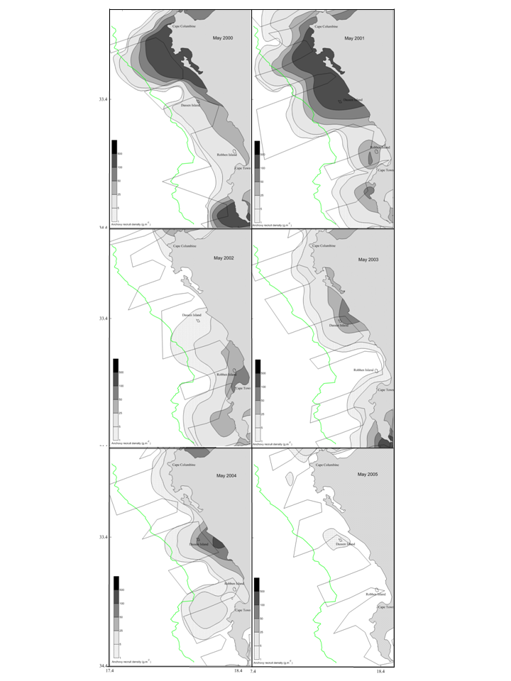

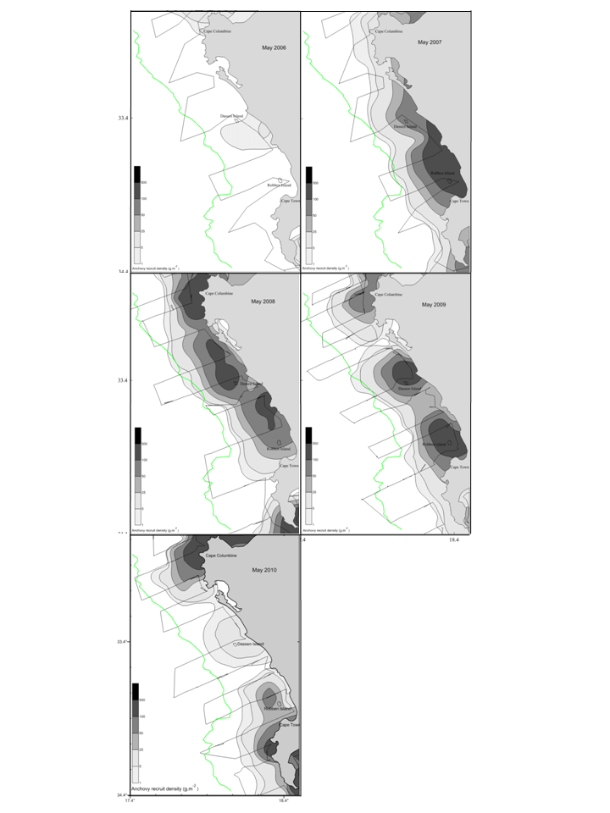

**Figure B.1.** Recruit densities between Cape Columbine and Cape Point for anchovy, from 2000 to 2010. The green line depicts a distance of 25 nmi from the coast.

1. * MARAM (Marine Resource Assessment and Management Group), Department of Mathematics and Applied Mathematics, University of Cape Town, Rondebosch, 7701, South Africa.
2. The simple manner in which the stochasticity in recruitment is introduced does allow the possibility of the monthly catch exceeding the number of recruits available. In calculations, however, this occurred in less than 2% of cases and so does not influence the results reported here.
3. Time constraints precluding ordering stochastic realisations for exact results, so the approximation of +- 1.96 standard deviations was used.
4. Taken as half the catch for that month, as catch data were available only at the monthly scale.