Summary of penguin–pelagic fish interaction modelling during 2008

William Robinson, Éva Plagányi, Doug Butterworth and Carryn de Moor

MARAM (Marine Resource Assessment and Management Group)

Department of Mathematics and Applied Mathematics,

University of Cape Town

August 2010

# Abstract

This document consolidates a series of papers developed during 2008 to inform the MCM Pelagic Working Group on the possible implications for future trends in penguin numbers at the Robben and Dassen Island colonies of reducing future TAC for sardine and anchovy. It details the penguin population model used and how this was fitted to available data on penguin abundance, as well as the inclusion of terms describing the effects of changing sardine and anchovy abundance on penguin reproduction and survival rates. This penguin model is projected forward under the scenarios for future sardine and anchovy abundance trajectories that were used in developing the current sardine-anchovy OMP, and variants of that OMP which involve further reductions in TACs at low sardine and anchovy abundance levels. An appendix lists all the data taken into account in these analyses.

# Introduction

Given the move towards adopting an ecosystem approach to fisheries in the pelagic sector, the joint Operational Management Procedure (OMP) for anchovy and sardine (de Moor and Butterworth 2008) needs to be tested in the light of not only the risk parameters relating to the fish stocks along with catch statistics, but also parameters denoting risk to predators such as the African penguin *Spheniscus demersus.* Penguins have been chosen as a key predator species to consider because of a recent marked deterioration in their conservation status, and because of their potential sensitivity to changes in pelagic fish abundance and distribution as a consequence of their land-based breeding sites. A model of penguin dynamics has been developed for use as a penguin Operating Model to be coupled to the pelagic fish OMP. This paper outlines the model structure and the method for evaluating the impact on penguins of predicted future pelagic fish trajectories under alternative harvest strategies (OMPs), and lists the results presented to MCM’s Pelagic Working Group during 2008.

# Data

A compilation of all data available as inputs to this and earlier penguin models is presented in Appendix A (see Plagányi and Robinson 2008). Comments in that appendix inform as to how the data have been used in these models, and there are notes on their derivation and potential reliability. Penguin data include counts of adult and immature moulters, nest counts and annual fledging success. Pelagic fish data series include the proportion of biomass located between Cape Columbine and Cape Point (designated “stratum B”) in the November acoustic survey, as well as spawner biomass and recruit abundances as estimated by the assessment model.

# Methods

## Penguin colonies considered

The early penguin models developed (see e.g. Plagányi and Butterworth 2007a, Robinson and Plagányi 2008a) were spatial in that several different populations of penguins were represented, and movement between these populations could be modelled. The four penguin colonies considered were Dassen Island, Robben Island, Dyer Island and Boulders. Dyer Island was included because after the Dassen and Robben colonies it has the next largest numbers of penguins, declines in the population there were of concern and it was considered an important breeding site for penguins given the eastward shift of sardines (Coetzee *et al*. 2008). Although relatively small, Boulders was also considered important to include because of its position, its role as the focus of several other studies and because of movements of penguins to colonise Boulders. Penguins were known to have emigrated from Dyer Island to Boulders, Robben and Dassen, and hence the model was used to quantify to what extent movement of birds away from Dyer Island could account for observed declines at Dyer and increases at these other colonies. The Algoa Bay component was similarly included in early model versions but subsequently removed from the model in response to comments received that westward migration is likely negligible, and the Algoa data series were considered unreliable.

These analyses (Plagányi and Butterworth 2007a, Robinson and Plagányi 2008a) showed that trends in penguin abundance at the major Western Cape colonies (Robben, Dassen, Boulders and Dyer) are best explained when taking movement of juvenile birds between these colonies into account. However, numbers at Boulders had steadied by the year 2000 and the numbers at Dyer Island are relatively small. Moreover, the Dassen Island and Robben Island colonies host the large majority of the region’s penguin population. Thus, in the interests of simplicity for a first attempt to model interactions with pelagic fish explicitly, it was decided to restrict attention to these two large colonies only (Robinson *et al*. 2008a). No explicit migration of birds between colonies was included in the model. Given likely different functional relationships between penguins and their fish prey at Dassen Island and Robben Island, aspects of these two penguin populations are modelled separately but within a common model framework when performing forward projections.

## Model

The main focus of the 2008 model described below is on Dassen Island and Robben Island.

### Population dynamics

The penguin model time step is one year. Penguins in each of the two major West Coast colonies at Robben Island and Dassen Island are modelled starting in 1986.

If  is the number of female penguins on 1 April in year  of age  at island  (where  is either Robben Island or Dassen Island), the population dynamics equations are as follows:

 for 

 for 

 for 

where the number of potential breeders each year is the sum of adults aged 4 and over:



and the density dependent reproductive success (which incorporates breeding success and survival until the end of the first year) is:



Other parameters and constants are defined as follows:

 is the maximum observed fledging success at the two islands, equal to 1.3717 chicks per pair per year;

 is the annual adult survival rate at island ;

 is what the annual reproductive success at island  would be were it not for density dependent effects;

 is the plus group age, set at 4 years; and

 is a carrying capacity-related factor used for calculating density dependent reproductive success at island . The values are 24 436 for Robben Island and 186 400 for Dassen Island.[1]

Assuming that the populations are in equilibrium in the starting year (1986), the initial age structure is calculated from the estimated initial number of breeders,  at the island concerned:

 for 

 for 

 for 

The number of juvenile and adult moulters on 1 December (the peak of the moult season) each year is given by





The proportion of juveniles in the total moult count is



Sardine and anchovy population dynamics were separately modelled using age structured production models (de Moor and Butterworth 2007a,b). For both species a single stock was assumed to be distributed throughout the western and southern coasts of South Africa. The model parameters were estimated using 23 years of data from hydroacoustic surveys and commercial catch data.

### Annual variation in adult survival and reproductive success

The model allows both adult survival and reproductive success to depend on the pelagic fish abundance each year as follows:

 

 

The constants , , and  as well as the random effects  and  are treated as estimable parameters. The pelagic abundance index in year ** is , calculated by



where:

 is the assessment model predicted anchovy biomass in year ,

 is the assessment model predicted sardine biomass in year ,

 is the proportion of anchovy biomass observed in stratum B in the acoustic survey in year ,

 is the proportion of sardine biomass observed in stratum B in the acoustic survey in year , and

 is the maximum combined biomass predicted to be in stratum B during the period 1985–2006.

For realism, an upper bound on adult survival  of 0.96 is imposed.

### Additional mortality due to oiling

Two major oil spills affected marine birds on the West Coast in 1994 and 2000. This is incorporated in the model by including an extra mortality term in these two years, resulting in the loss of 2500 female birds in 1994 and 1000 female birds in 2000. The proportion assumed to be from Robben Island is 40%, and from Dassen 60%, in each case. Also, an additional 20% of birds in their first year are assumed to die in these two years.

### Fitting procedure

Input values assumed for the base case application of the model above are listed in Appendix B (see also Robinson *et al*. 2008b). Note in particular that:

* The standard deviations of the random effects components for both annual survival and reproductive success are set high so as not to exclude any rather large variations over time that the data overall might suggest.
* It is assumed that at both Robben Island and Dassen Island the nest count is thorough, including nearly all breeding pairs. Hence a high proportionality constant for breeders  is chosen, namely 0.95. Likewise, the count of Robben Island coastal moulters is thought to be a reasonably accurate measure of the population since very few birds have been observed moulting inland (Crawford and Boonstra 1994), so that  was set equal to 0.9. This is not the case at Dassen Island, so the constant  is estimated.

The model is fitted to adult moult counts , the proportion of juveniles observed in the moult count , as well as counts of the numbers of breeders . The model values are multiplied by the proportionality constants  for moulters and  for breeders. For Dassen Island,  is estimated within the model by

,

where  is the number of years for which there are Dassen Island moult counts available.

Contributions to the overall negative log-likelihood are as follows:







where the summations are over the years in which counts were made and over the two islands. Penalty terms are added to the total negative log-likelihood for the estimated random effect residuals as follows:





Hence the overall negative log likelihood is given by:



The estimable parameters of the model are:

* the initial numbers of breeders  at Robben Island and Dassen Island,
* the prey relationship slopes  and  at each island,
* the prey relationship intercepts  and  at each island
* the random effects in juvenile survival  for each year  and island , and
* the random effects in adult survival  for each year  and island .

## Coupling the pelagic OMP and penguin population model

### Projections

Using the base case Operating Model for OMP-08, 1000 plausible biomass trajectories for the years 2007–2027 were produced for each of anchovy  and sardine . For each set of trajectories  and each year , the index for the proportion of biomass found in stratum B is calculated by:



where  and  are drawn randomly from a sample of recent (2002–2006) observed proportions. Note that projections are based on the assumed continuation of recent low biomass in stratum B (see Fig. A.2), rather than a change back to earlier higher levels (see point 4 of Appendix B).  is the maximum combined stratum B biomass estimated for the past, as in equation .

For the last year of penguin count data, 2007, the median values of the 1000 anchovy and sardine scenarios for that year are used in equation , along with the median values of the 2002–2006 stratum B proportions.

Assuming the functional relationships between these quantities and penguin parameters in equations –, the penguin model can be projected forwards under each of these 1000 scenarios, and the risk to penguins evaluated as described below.

For future years, the random effects  and  are sampled from colony-specific Normal distributions with the same standard deviations as the vectors of estimated parameters  and  , rather than the values input for the original assessment  and .

As the model is stochastic, multiple replications (typically 25 to keep computation time reasonable) are conducted for each scenario, and each time the future penguin numbers are calculated and recorded for the years 2008–2027. Calculating the median of each set of replicates gives a distribution of 1000 future penguin population trajectories.

### Additional Exceptional Circumstances rule

Modifications to OMP-08 to take account of the foraging needs of penguins were tested (de Moor 2008). The alternative rules apply an equal percentage decrease to the directed sardine and anchovy TACs if the total sardine and anchovy biomass is below a set threshold . The alternative rules are applied after the TAC has been calculated using OMP-08 as it currently stands (de Moor and Butterworth 2008). Thus there is no change to the control parameters of OMP-08 and all other constraints and/or Exceptional Circumstances are applied before this additional alternative rule is applied (Figure 11):

Alternative 1: 

Alternative 2: 

The alternative rules are applied before the TAB is calculated and thus if the anchovy TAC is decreased due to the total sardine and anchovy biomass being below the threshold, the TAB will also be adjusted accordingly.

The threshold  chosen was 4 239 000t, corresponding to the median projected total sardine and anchovy biomass in 2027 under OMP-08. Alternative less conservative thresholds, for which results were computed but are not shown below include 2 826 000t (66% of the median projected total sardine and anchovy biomass in 2027 under OMP-08) and 1 413 000t (33% of the median projected total sardine and anchovy biomass in 2027 under OMP-08).

# Results

Table 1 gives the estimated parameters for the base case model, as well as the negative log likelihood values (see also Robinson and Plagányi 2008b). The base-case model fits to the available data for Robben Island and Dassen Island are shown in Figure 1 (moult counts), Figure 2 (breeding pair counts) and Figure 3 (proportion of moulters which are juvenile). Figure 4 shows the model-estimated reproductive success and adult survival relationships corresponding to the stratum B biomass index, with 95% Hessian-based confidence intervals. The corresponding time series are plotted in Figure 5 and Figure 6.

Figure 7 and Figure 8 present a set of projections for this penguin model for different OMPs. For this set of results, the sample of observed stratum B proportions is from the years 2002–2006 when pelagic abundance was extremely low, especially in this region. Projections of penguin abundances for 20 years are shown. The distributions of results for 1000 simulations show that the median penguin abundances for the pelagic series with catch are slightly lower than those for the pelagic series without catch (Figure 9), with a larger effect at Robben Island. The stratum B pelagic abundance index is shown in Figure 10.

## Penguin/pelagic catch trade-off

Figure 11 shows schematically how the sardine and anchovy TACs are reduced under the additional Exceptional Circumstances rules given in equations –. Figure 12 shows the impact that these rules have on the projected combined sardine and anchovy biomass in 2027. The median and lower 5 percentile biomass values are listed in Table 2 and Table 3. The ratio of the alternative catch scenarios to the no-catch scenario are compared in Table 4. Although there is little difference at the median level, the difference between the alternatives is noticeable at the lower 5 percentile level. This is as would be expected, given that this rule was designed to lower the TAC only when the total biomass is low.

Table 5 (for anchovy) and Table 6 (for directed sardine) show the effect on the average, median and lower 5 percentile of the projected catches over the next 5 and 20 years.

Figure 13 compares results for projected penguin abundances at Robben Island and Dassen Island under the base case model with a model which assumes no relationship between penguin survival and pelagic biomass. Both models indicate a decline in penguin numbers at Dassen Island, while an increase in penguin numbers is predicted at Robben Island if no penguin–pelagic biomass relationship is assumed. The base case model suggests that fishing has a negative impact on penguin abundance at Robben Island, but not at Dassen Island.

The final result of this work (see also Robinson *et al.* 2008c) is a comparison of trade-offs between penguin abundance in 2018 and projected median pelagic catches over the next 20 years. Projected total penguin numbers at Robben Island and Dassen Island are compared under different anchovy and sardine catch scenarios for different penguin-related Exceptional Circumstances rules, relative to OMP-08.

Figure 14 shows the predicted change in total penguin numbers for each island under each future catch scenario. The highest average catches correspond to the current OMP-08 projections, with Alternative 1 (70% rule) and Alternative 2 (20% rule) corresponding to successively lower catches. The figures suggest that appreciable benefits to penguins are only achieved at Robben Island for very sizeable reductions in pelagic catch, while even taking no catch at all would hardly be of benefit to penguins at Dassen Island.

# Discussion

Risk can be quantified as the probability of penguin abundance (either in terms of the numbers of breeding pairs or total population size) dropping below some threshold abundance under different OMP variants. However, relative depletion cannot simply be based on historic estimates of carrying capacity because of the possibility that penguin numbers at the turn of the 19th century may have been artificially high due to a competitive release effect as a result of the heavily reduced seal numbers at the time following intensive harvesting. Moreover, Crawford *et al*. (2007) propose a change in carrying capacity from a very high level in the 1920s to a much lower value over the period 1978–2006.

Thus, consistent with the approach adopted during the development of the pelagic OMP, we recommend assessing risk by comparing distributions of penguin abundance under different fish harvesting strategies to those under comparable no-fishing trials (Butterworth 2008).

The results for a wide range of sensitivity analyses are presented in Appendix B. The model projections were found to be particularly sensitive to both the pelagic biomass stratum used and also the sample of biomass proportions used for projections.

# Acknowledgements

We are grateful for data from Rob Crawford and Les Underhill, as well as inputs from both them and the rest of penguin task group. Thanks go to Janet Coetzee for providing pelagic fish abundance estimates, and also to Marine and Coastal Management and the National Research Foundation for financial support.

# References

Butterworth DS. 2008. Some lessons from implementing management procedures. In: Tsukamoto K, Kawamura T, Takeuchi T, Beard TD, Kaiser MJ (eds), *Fisheries for Global Welfare and Environment, 5th World Fisheries Congress.* pp 381–397.

Coetzee JC, van der Lingen CD, Hutchings L, Fairweather TP. 2008. Has the fishery contributed to a major shift in the distribution of South African sardine? *ICES Journal of Marine Science* 65: 1676–1688.

Crawford RJM, Boonstra HGvD. 1994. Counts of moulting and breeding Jackass Penguins *Spheniscus demersus*: a comparison at Robben Island, 1987–1993. *Marine Ornithology* 22: 213–219.

Crawford RJM, Shannon LJ, Whittington PA. 1999. Population dynamics of the African penguin *Spheniscus demersus* at Robben Island, South Africa. *Marine Ornithology* 27: 139–147.

Crawford RJM, Davis SA, Harding RT, Jackson LF, Leshoro TM, Meÿer MA, Randall RM, Underhill LG, Upfold L, van Dalsen AP, van der Merwe E, Whittington PA, Williams AJ, Wolfaardt AC. 2000. Initial impact of the *Treasure* oil spill on seabirds off western South Africa. *South African Journal of Marine Science* 22: 157–176.

Crawford RJM, Barham PJ, Underhill LG, Shannon LJ, Coetzee JC, Dyer BM, Leshoro TM, Upfold L. 2006. The Influence of Food Availability on Breeding Success of African penguins *Spheniscus demersus* at Robben Island. *Biological Conservation* 132: 119–125.

Crawford RJM, Underhill LG, Upfold L, Dyer BM. 2007. An altered carrying capacity of the Benguela upwelling ecosystem for African penguins (*Spheniscus demersus*). *ICES Journal of Marine Science* 64: 570–576.

de Moor CL. 2008. Adjustments to OMP-08 to allow penguin foraging at low pelagic biomass. Document MCM/2008/SWG-PEL/29.

de Moor CL, Butterworth DS. 2007a. Assessment of the South African anchovy resource. Document MCM/2007/SEPT/SWG-PEL/05.

de Moor CL, Butterworth DS. 2007b. Base case assessment of the South African sardine resource. Document MCM/2007/SEPT/SWG-PEL/06.

de Moor CL, Buterworth DS. 2008. OMP-08. Document MCM/2008/SWG-PEL/23.

de Moor CL, Butterworth DS, Coetzee JC. 2008. Revised estimates of abundance of South African sardine and anchovy from acoustic surveys adjusting for echosounder saturation in earlier surveys and attenuation effects for sardine. *African Journal of Marine Science* 30: 219–232.

Plagányi ÉE, Butterworth DS. 2007a. Spatial age-structured model of African penguin populations at Robben, Dassen and Dyer Islands, and at Boulders. Document MCM/2007/MAY/SWG-PEL/6b.

Plagányi ÉE, Butterworth DS. 2007b. Revised spatial age-structured model of African penguin *Spheniscus demersus* populations. Document SWG/EAF/SEABIRDS/13APR07/03.

Plagányi ÉE, Robinson W. 2008. Data inputs for the African penguin *Spheniscus demersus* model to be coupled to the pelagic OMP. Document MCM/2008/SWG-PEL/26.

Randall RM. 1983. Biology of the Jackass Penguin *Spheniscus demersus* (L.) at St Croix Island, South Africa. PhD thesis, University of Port Elizabeth, South Africa.

Randall RM, Randall BM, Cooper J, la Cock GD, Ross GJB. 1987. Jackass penguin *Spheniscus demersus* movements, inter-island visits, and settlement. *Journal of Field Ornithology* 58: 445–455.

Robinson W, Plagányi ÉE. 2008a. Updated results from a spatial age-structured model of African penguin populations for use in linking to the pelagic OMP testing process. MCM/2008/SWG-PEL/21b.

Robinson W, Plagányi ÉE. 2008b. Further analyses using the penguin model coupled to the pelagic OMP. Document MCM/2008/SWG-PEL/30.

Robinson W, Plagányi ÉE, Butterworth DS. 2008a. Illustrative outputs of the age-structured model of African penguin populations for linking to the pelagic OMP testing process. Document MCM/2008/SWG-PEL/27.

Robinson W, Plagányi ÉE, Butterworth DS. 2008b. Summary of sensitivity analyses using the base-case penguin model. Document MCM/2008/SWG-PEL/28.

Robinson W, de Moor CL, Plagányi ÉE. 2008c. Penguin/pelagic catch trade-off. Document MCM/2008/SWG-PEL/31.

Underhill LG, Bartlett PA, Baumann L, Crawford RJM, Dyer BM, Gildenhuys A, Nel DC, Oatley TB, Thornton M, Upfold L, Williams AJ, Whittington PA, Wolfaardt AC. 1999. Mortality and survival of African penguins *Spheniscus demersus* involved in the *Apollo Sea* oil spill: an evaluation of rehabilitation efforts. *Ibis* 141: 29–37.

Underhill LG, Crawford RJM. 1999. Season of moult of African penguins at Robben Island, South Africa, and its variation, 1988–1998. *South African Journal of Marine Science* 21: 437–441.

Underhill LG, Crawford RJM, Wolfaardt AC, Whittington PA, Dyer BM, Leshoro TM, Ruthenberg M, Upfold L, Visagie J. 2006. Regionally coherent trends in colonies of African penguins *Spheniscus demersus* in the Western Cape, South Africa, 1987–2005. *African Journal of Marine Science* 28: 697–704.

Whittington PA. 2002. Survival and movements of African penguins, especially after oiling. PhD thesis, University of Cape Town, South Africa.

Whittington PA, Randall RM, Crawford RJM, Wolfaardt AC, Klages NTW, Randall BM, Bartlett PA, Chesselet YJ, Jones R. 2005a. Patterns of immigration to and emigration from breeding colonies by African penguins. *African Journal of Marine Science* 27: 205–213.

Whittington PA, Randall RM, Randall BM, Wolfaardt AC, Crawford RJM, Klages NTW, Bartlett PA, Chesselet YJ, Jones R. 2005b. Patterns of movement of the African penguin in South Africa and Namibia. *African Journal of Marine Science* 27: 215–229.

# Tables and figures

Table 1: Comparison of estimated parameters, likelihoods, AIC and AICc for the base case model and an alternative model which includes no relationships between pelagic biomass and either adult survival or reproductive success .

|  |  |  |
| --- | --- | --- |
|  | Base case | No relationship with biomass |
| (Robben reproductive success intercept) | -0.74 | -0.52 |
| (Robben reproductive success slope) | 0.00 |  |
| (Robben adult survival intercept) | 0.80 | 2.14 |
| (Robben adult survival slope) | 47.19 |  |
| (Dassen reproductive success intercept) | -0.71 | -0.43 |
| (Dassen reproductive success slope) | 1.36 |  |
| (Dassen adult survival intercept) | 1.42 | 1.42 |
| (Dassen adult survival slope) | 0.00 |  |
| -lnL | -133.088 | -131.383 |
| Number of parameters estimated | 90 | 86 |
| Number of observations | 109 | 109 |
| AIC | -86.176 | -90.766 |
| AICc | 823.824 | 589.416 |

Table 2: Median projected total sardine and anchovy biomass (million tons) in 2027 under a zero catch scenario, under OMP-08, and under the two alternative penguin-related Exceptional Circumstances rules.

|  |  |  |  |  |
| --- | --- | --- | --- | --- |
|  | No Catch | OMP-08 | Alternative 1 (70%) | Alternative 2 (20%) |
| Sardine | 3.44 | 2.48 |  |  |
| Anchovy | 2.42 | 1.15 |  |  |
| Total Sardine & Anchovy | 6.77 | 4.24 | 4.45 | 4.68 |

Table 3: Lower 5%ile projected sardine and anchovy biomass (million tons) in 2027 under a zero catch scenario, under OMP-08 and under the two alternative penguin-related Exceptional Circumstances rules.

|  |  |  |  |  |
| --- | --- | --- | --- | --- |
|  | No Catch | OMP-08 | Alternative 1 (70%) | Alternative 2 (20%) |
| Sardine | 1.48 | 0.41 |  |  |
| Anchovy | 0.78 | 0.18 |  |  |
| Total Sardine & Anchovy | 3.05 | 1.22 | 1.67 | 2.02 |

Table 4: The ratio of projected median and lower 5%ile total sardine and anchovy biomass in 2027 under OMP-08 and under the two alternative penguin-related Exceptional Circumstances rules to that under a zero catch scenario.

|  |  |  |  |
| --- | --- | --- | --- |
|  | OMP-08: No Catch | Alternative 1 (70%): No Catch | Alternative 2 (20%): No Catch |
| Median | 0.63 | 0.66 | 0.69 |
| Lower 5%ile | 0.40 | 0.55 | 0.66 |

Table 5: Average directed anchovy catches (in ‘000t) under OMP-08 and the two alternative penguin-related Exceptional Circumstances rules for 20 year and 5 year projections. The percentage reduction from OMP-08 to the alternatives are also shown.

|  |  |  |  |  |  |
| --- | --- | --- | --- | --- | --- |
|  | OMP-08 | Alternative 1 (70%) | % Reduction | Alternative 2 (20%) | % Reduction |
| 2008–2027 |  |  |  |  |  |
| Average | 381 | 361 | 5.2% | 333 | 12.7% |
| Median | 400 | 349 | 12.9% | 301 | 24.9% |
| Lower 5%ile | 66 | 77 | -16.4% | 62 | 6.0% |
| 2008–2012 |  |  |  |  |  |
| Average | 434 | 401 | 7.4% | 361 | 16.7% |
| Median | 467 | 395 | 15.5% | 332 | 28.9% |
| Lower 5%ile | 141 | 124 | 11.9% | 83 | 40.8% |

Table 6: Average directed sardine catches (in ‘000t) under OMP-08 and the two alternative penguin-related Exceptional Circumstances rules for 20 year and 5 year projections. The percentage reduction from OMP-08 to the alternatives are also shown.

|  |  |  |  |  |  |
| --- | --- | --- | --- | --- | --- |
|  | OMP-08 | Alternative 1 (70%) | % Reduction | Alternative 2 (20%) | % Reduction |
| 2008–2027 |  |  |  |  |  |
| Average | 190 | 186 | 2.4% | 180 | 5.4% |
| Median | 152 | 142 | 6.3% | 133 | 12.7% |
| Lower 5%ile | 90 | 70 | 21.8% | 45 | 50.1% |
| 2008–2012 |  |  |  |  |  |
| Average | 131 | 125 | 4.7% | 117 | 10.8% |
| Median | 115 | 109 | 5.8% | 100 | 13.0% |
| Lower 5%ile | 90 | 73 | 19.2% | 47 | 45.6% |

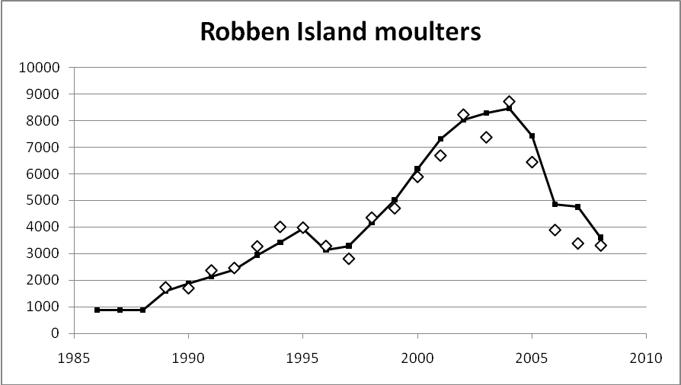

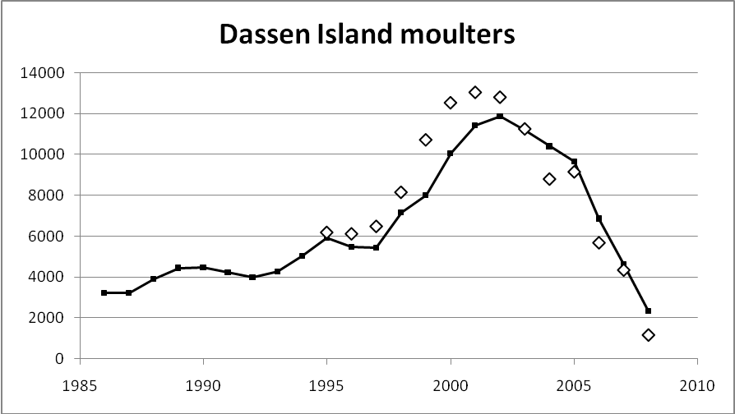

Figure 1: Base-case model-predicted trajectories of the numbers of female moulting penguins at Robben Island (top panel) and Dassen Island (lower panel). Observed data are shown as diamond symbols not joined by a line.

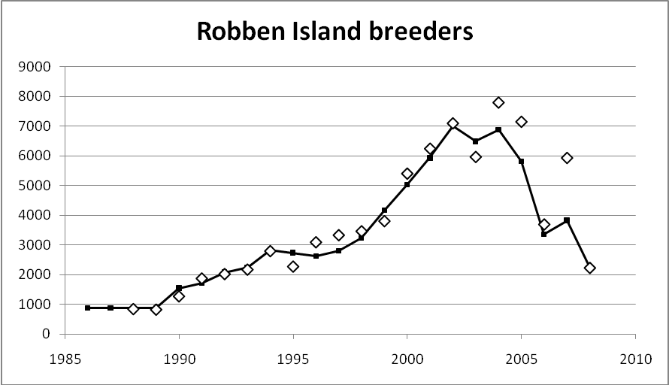

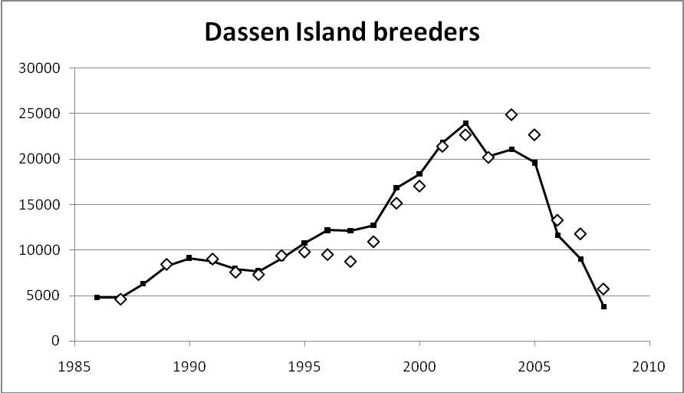

Figure 2: Base-case model-predicted trajectories of the numbers of breeding pairs at Robben Island and Dassen Island. Observed data are shown as diamond symbols not joined by a line.

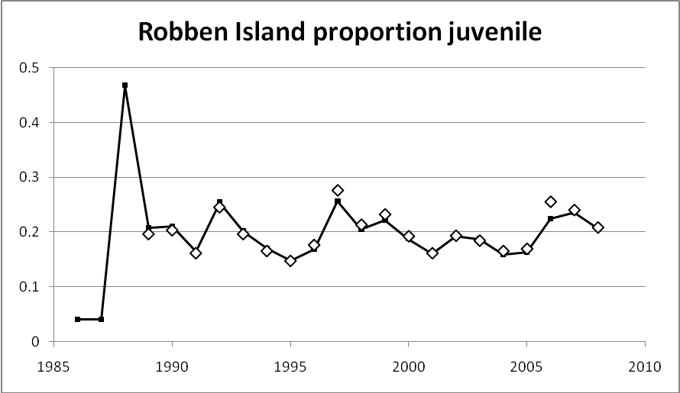

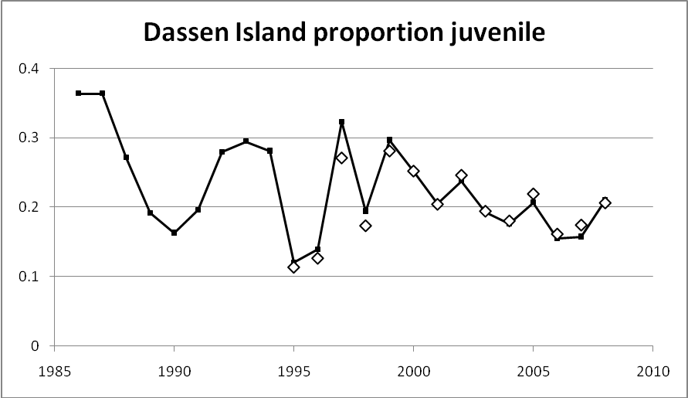

Figure 3: Base-case model-predicted trajectories of the proportion of juvenile birds at Robben Island and Dassen Island. Observed data are shown as diamond symbols not joined by a line.

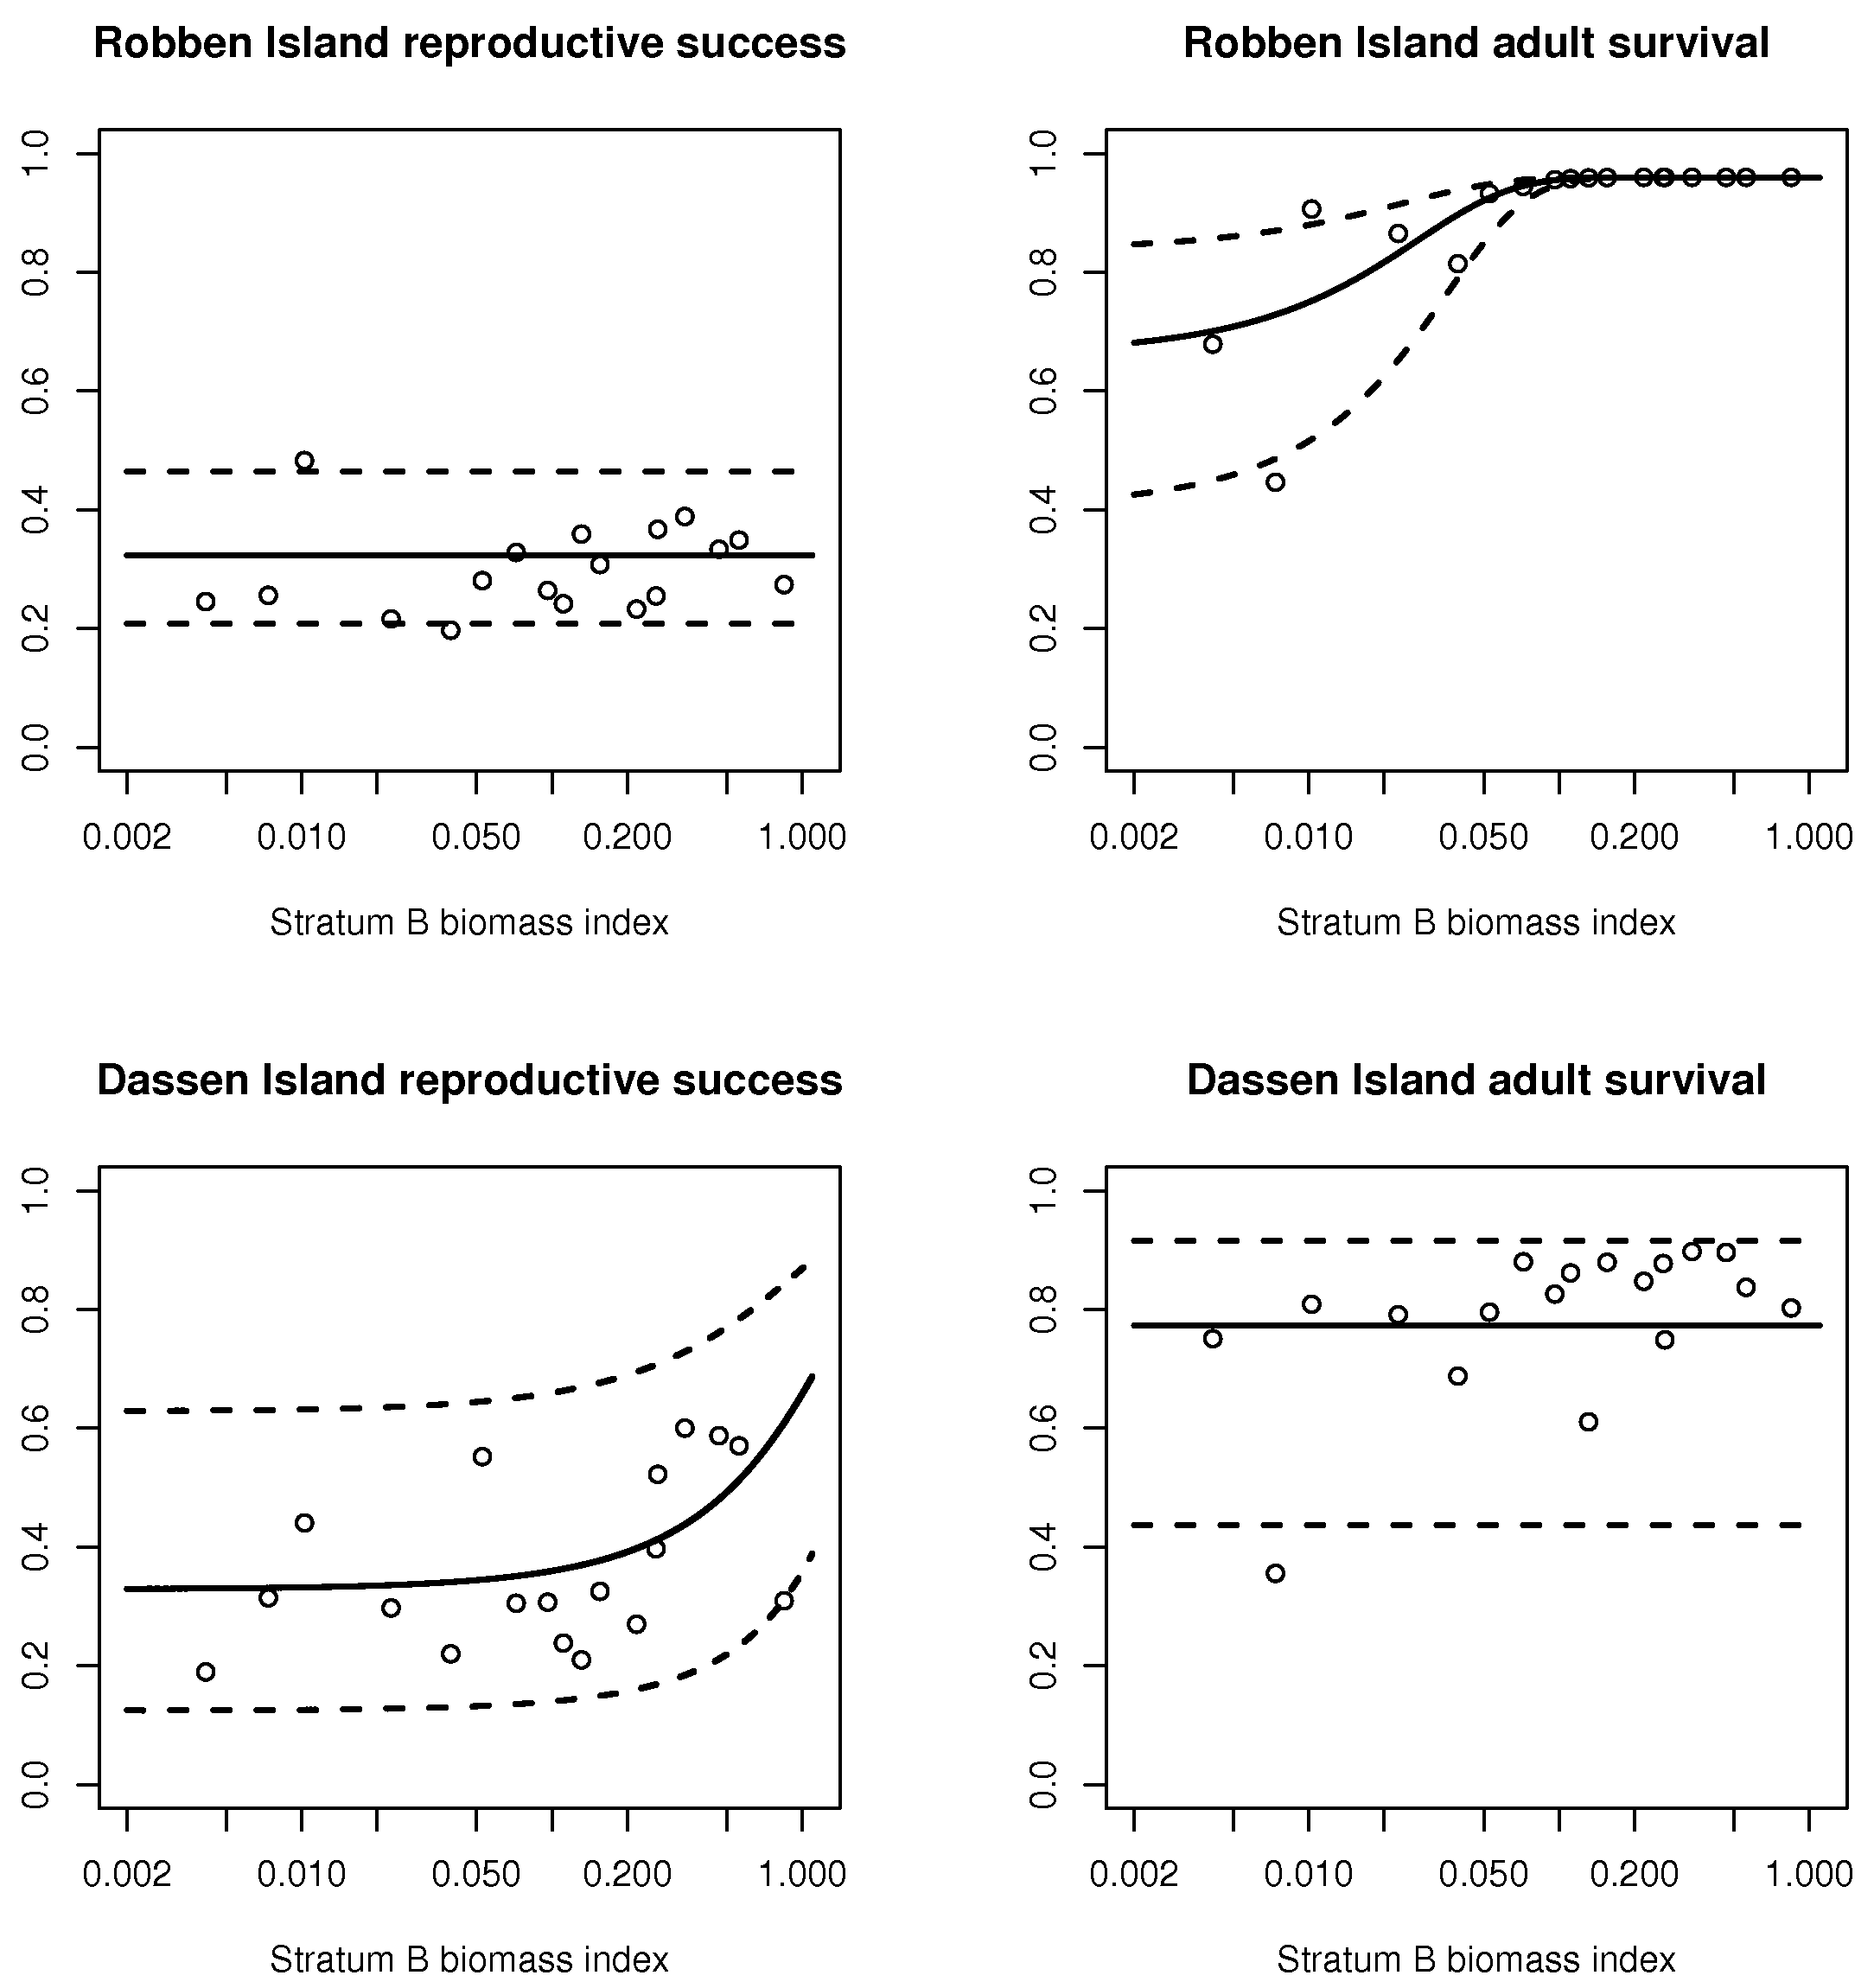

Figure 4: Deterministic reproductive success (left) and adult survival (right) with 95% confidence intervals for Robben Island (top) and Dassen Island (bottom) for the base case model. Circles indicate model-estimated survival values. The stratum B biomass index is calculated by multiplying the assessment model-predicted anchovy and sardine biomasses with the proportions observed in stratum B in the survey, summing, and dividing by the maximum of the series developed in this manner. A logarithmic scale is used on the horizontal axis in order to show the behaviour at low biomass indices more clearly.

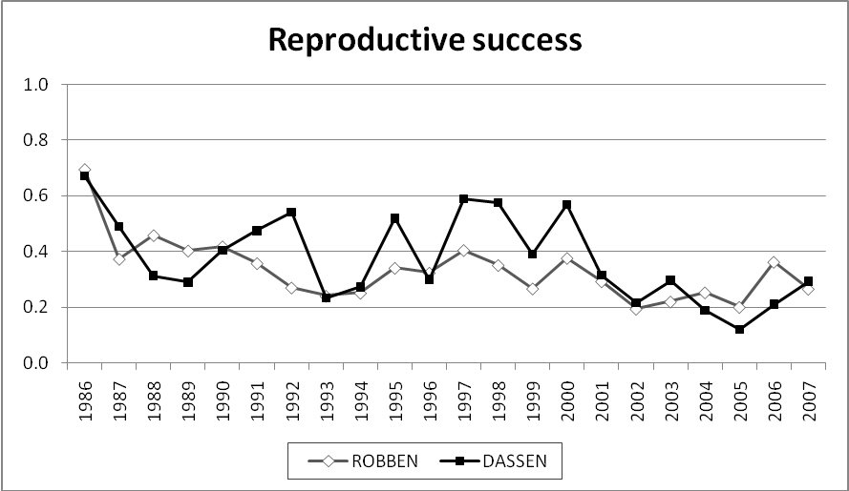

Figure 5: Base-case model estimates of relative reproductive success (which encompasses breeding effort, fledging success and survival to the end of the first year) for Robben Island (diamond symbols) and Dassen Island (square symbols).

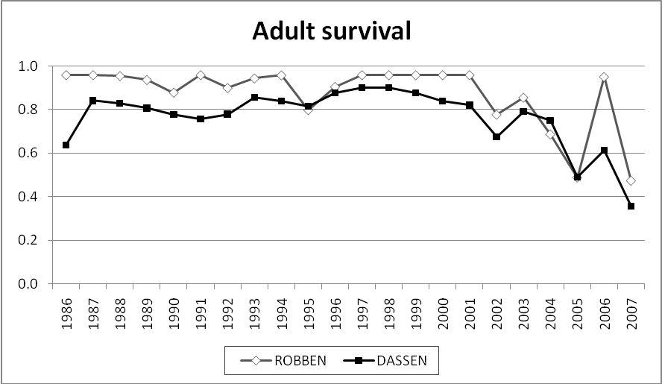

Figure 6: Base-case model estimates of adult survival rate for Robben Island (diamond symbols) and Dassen Island (square symbols).

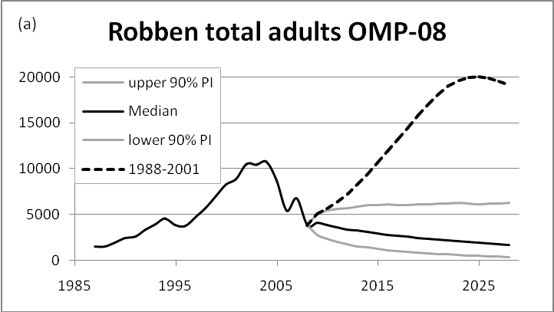 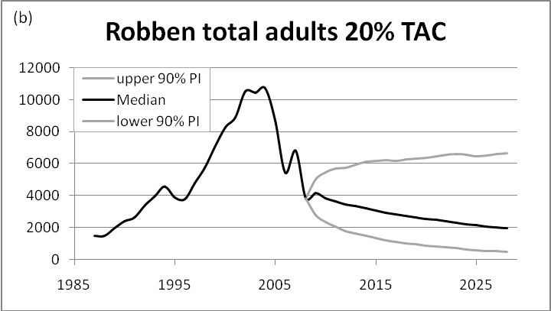

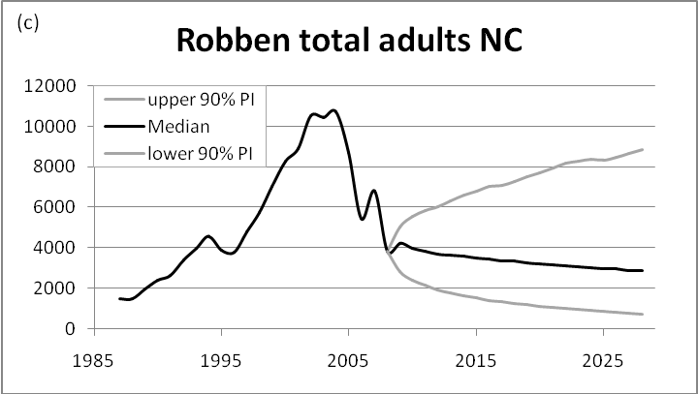 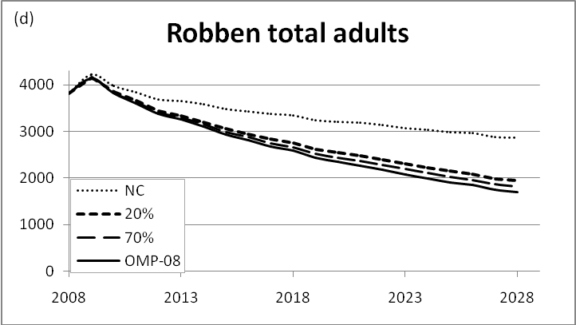

Figure 7: Robben Island population projections with probability intervals under various fishing management procedures: (a) OMP-08 TAC unchanged, (b) 20%–100% of TAC allocated when biomass drops below the median, (c) no fishing and (d) projections for four cases shown together. Future stratum B proportions are drawn from the 2002–2006 set, except for the dashed line in (a) which indicates a projection sampling from the 1988–2001 set.

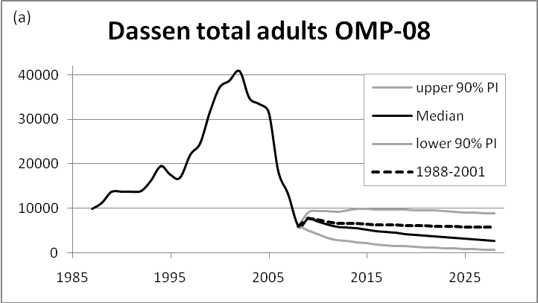 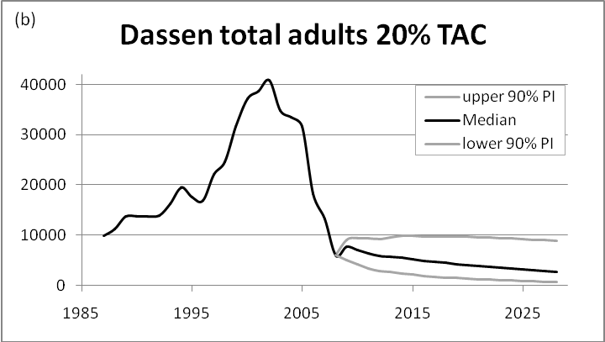

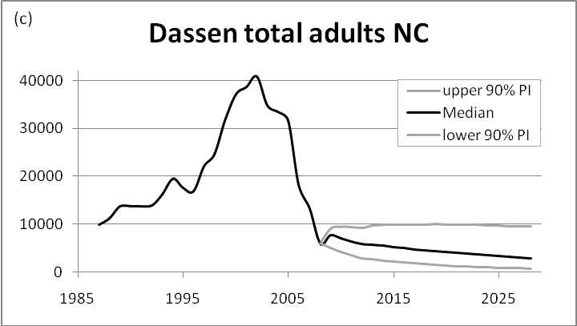 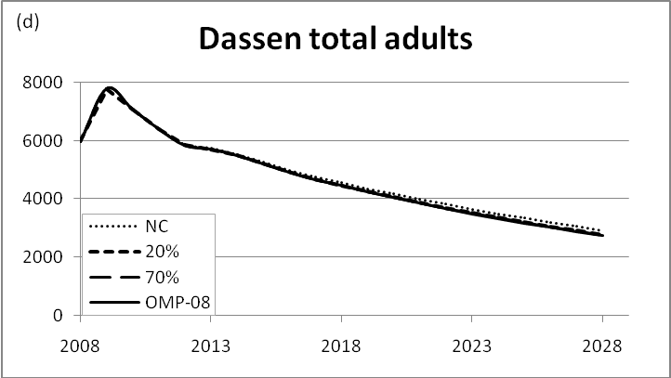

Figure 8: Dassen Island population projections with probability intervals under various fishing management procedures: (a) OMP-08 TAC unchanged, (b) 20%–100% of TAC allocated when biomass drops below the median, (c) no fishing and (d) projections for four cases shown together. Future stratum B proportions are drawn from the 2002–2006 set, except for the dashed line in (a) which indicates a projection sampling from the 1988–2001 set.

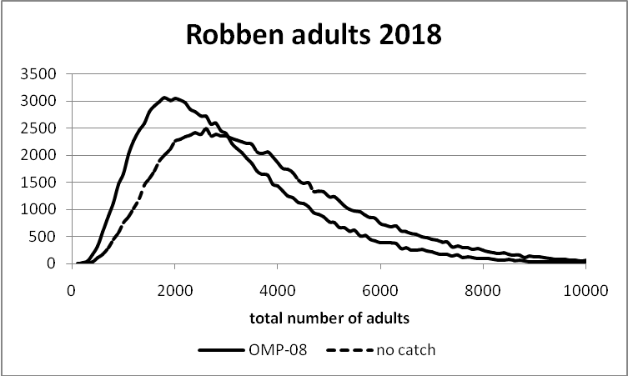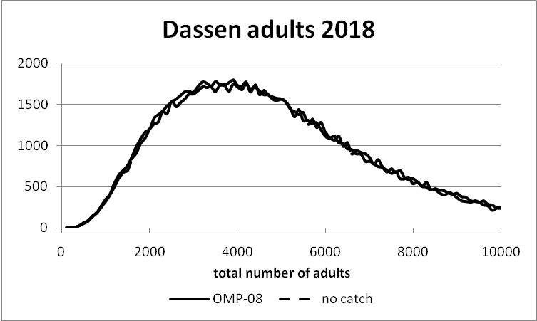

Figure 9: Distributions of 2018 penguin populations over 100 000 runs. On the left we see a shift to the right (higher penguin abundance) in the absence of fishing, but the distributions are very broad. On the right it is evident that in the model, fishing has no effect on the Dassen Island population, which is consistent with results shown in Figure 8.

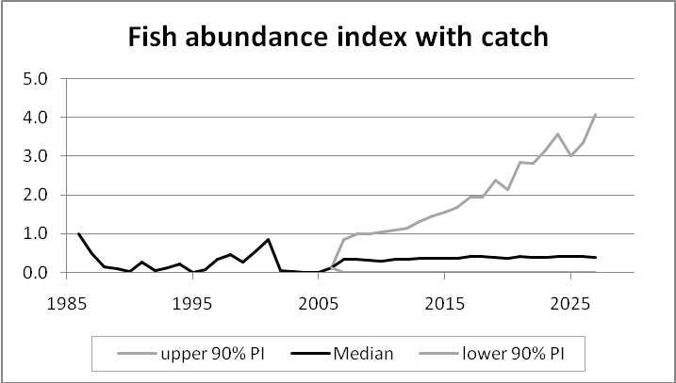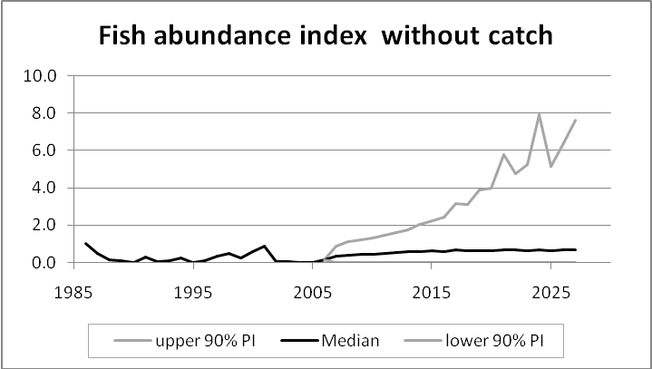

Figure 10: Median and 90% probability intervals for the pelagic abundance index calculated with the 1988–2001 sample of stratum B proportions.



Figure 11: The proportion by which the directed sardine and anchovy TACs are decreased under penguin-related Exceptional Circumstances.



Figure 12: The distribution of the projected total sardine and anchovy biomass in 2027 under a no catch scenario, under OMP-08 and under the two alternative penguin-related Exceptional Circumstances rules.

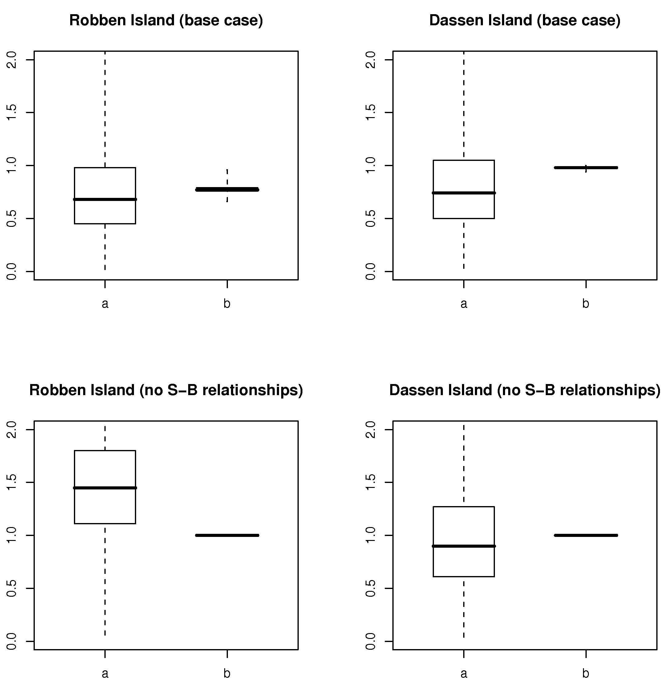

Figure 13: Results pertaining to the base case model (top) and the model with no relationships between penguin dynamics and pelagic fish abundance (bottom). The labelled box plots (which indicate the median, upper and lower quartiles, and minimum and maximum values) in each subplot show:

1. The ratio of penguin abundance in 2018 to 2008 under OMP-08. Values less than 1 indicate a decrease in penguins.
2. The ratio of penguin numbers in 2018 under OMP-08 to numbers in 2018 under no fishing. Values less than 1 indicate that fishing has a negative effect on penguin abundance.

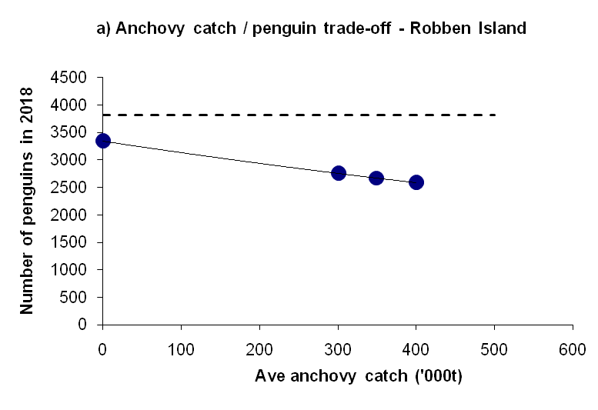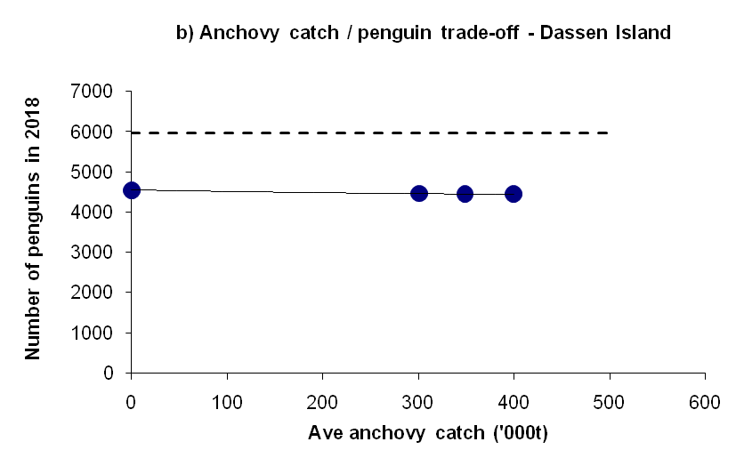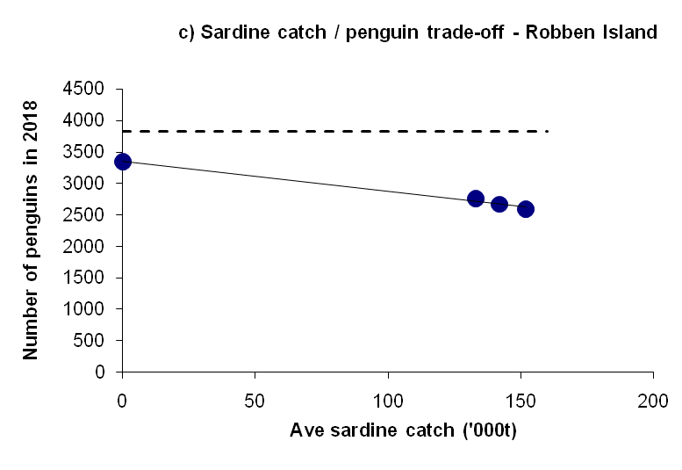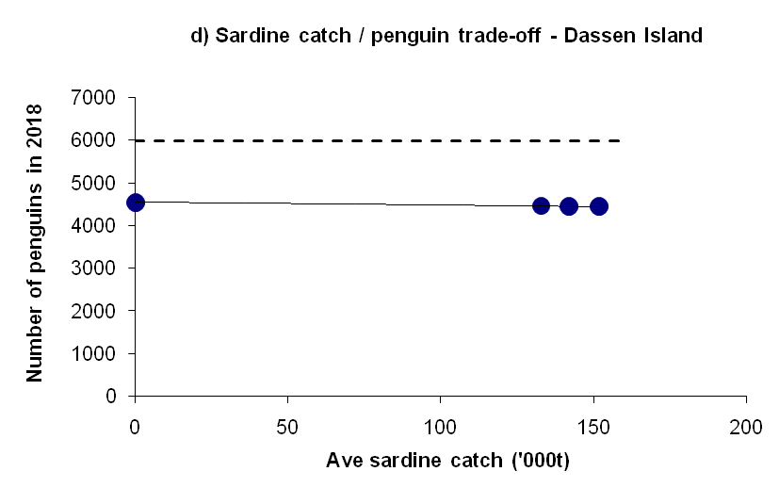

Figure 14: Plots of the base-case model-predicted median penguin numbers in 2018 plotted as a function of a range of anchovy (a,b) and sardine (c,d) median catch values averaged over 2008–2027. The dashed lines indicate the 2008 penguin population sizes for Robben Island (a,c) and Dassen (b,d) Island, as calculated by the model. This example is based on using the 2002–2006 sample of biomass proportions to compute future anchovy and sardine abundance in the Cape Point to Cape Columbine area, which includes Robben Island and Dassen Island.

# Appendix A – Data

A map indicating all the breeding colonies of penguins in the Western Cape is provided in Figure A.1 which also shows the relative abundance of breeding pairs in the different sub-areas, computed from data in Underhill *et al.* (2006). The regional penguin population is dominated (in terms of numbers) by two large colonies, namely Robben Island and Dassen Island, with the next largest colonies being Dyer Island and Boulders.

Figure A.2 maps the extent of strata corresponding to pelagic fish biomass estimates used to link to penguin breeding success in the model. Initially relationships were investigated with the west of Cape Agulhas pelagic spawner biomass and the west of Cape Infanta recruit abundances rather than the total South African pelagic fish abundance (Robinson and Plagányi 2008a). In this paper, this has been refined further still to use the Cape Columbine to Cape Point spawner biomass component only, since this more accurately depicts the biomass available to penguins in the west coast model area. Inshore and offshore estimates were summed to obtain sardine and anchovy biomass series corresponding to the area between Cape Point and Cape Columbine (stratum B). The proportions of the total anchovy and sardine biomasses observed in stratum B were computed for each year. The assessment model biomass estimates for anchovy and sardine (de Moor and Butterworth 2007a,b) were multiplied by the proportions observed in stratum B. The results were summed to obtain a combined biomass series for stratum B. Dividing by the maximum value yielded the relative abundances used as the input series to the penguin model. The west of Cape Infanta recruit estimates are retained because the anchovy and sardine recruits move down the West Coast.

## Penguins

A summary of the timeline assumed for an “average” penguin is given in Figure A.3.

A number of time series, both published and unpublished, are available and have been used both to compare with model trends and for use in estimating parameters by fitting to these data. The two main forms of data are counts of the numbers of moulting birds at the various colonies and counts of breeding pairs (Table A.1). The data are from Underhill *et al.* (2006), and various published studies as well as recent updates provided by Les Underhill and Rob Crawford.

The adult moult count measures the size of the adult-plumaged population whereas the nest count measures the number of breeding pairs (L. Underhill, pers. commn). There are two slightly different series available describing the number of birds moulting at Robben Island, and the series used here are the set considered the more accurate of the two because they account for missing information (see Underhill and Crawford 1999).

It has been highlighted (Rob Crawford, pers. commn) that the counts are of birds moulting around the coastline but that at Dassen Island birds also moult in burrows and are not counted. Furthermore the counts at Dassen Island do not cover the interior where penguins may be found in appreciable numbers. Therefore, the count at Dassen Island is not of all birds moulting, just an index. Anton Wolfaardt and Les Underhill (pers. commn) have similarly confirmed that the Dassen Island moult counts should be treated as an index of abundance, and not as an estimate of the absolute number of penguins. Given that the moulting process takes two weeks, the sum of counts made at two week intervals provides an estimate of the total population moulting at the locality, following adjustments for the fact that the counts are not made at exactly this frequency. Crawford (pers. commn) notes that moulters will be undercounted at Robben Island to a lesser extent than at Dassen Island.

It has been noted that the Dyer moult count data are unreliable for some years due to cholera outbreaks at the peak moult period (Underhill, pers. commn). The following data from Dyer have thus been excluded from Table A1:

* 2001 (counts were not made in September and October 2000)
* 2003 (counts were not made in October and November 2002)
* 2005 (an important count is missing for the first half of October 2004, so the interpolation is not really satisfactory).

As the model represents numbers of female penguins, an even sex ratio was assumed and the numbers of moulters halved to derive an index of the number of female moulters (Table A.1).

Data to provide insights into the age structure are provided by Les Underhill in the form of adult and juvenile (birds undergoing first moult) penguin moult counts at Dassen, Robben and Dyer Islands (Table A.2).

It is notable that, when considering Robben and Dyer Islands, the number of female moulters per year is approximately the same or less, rather than substantially more, than the number of breeding females, and that this effect is considerably more marked for Dassen Island (Figure A.4). This indicates that only a proportion of the population is counted during the moult counts because, for example, counts do not cover the island interiors. It is assumed in the modelling exercise that the proportion of counted to uncounted birds remains approximately constant from year to year and that the moult counts provide a reliable index of population trends even though only a proportion of the population is counted.

Using data on the numbers of breeding pairs (from Underhill *et al.* 2006), the observed trends in the Western Cape as a whole are compared in Figure A.5 with the trend obtained when summing the numbers of breeding pairs included in a model encompassing Dassen Island, Robben Island, Boulders and Dyer Island (Robinson and Plagányi 2008a). This suggests that this earlier model (Robinson and Plagányi 2008a) accounts for over 90% of all penguins in the Western Cape. The model of this paper focuses on Dassen and Robben Islands only, which together account for 65% of all penguins in the Western Cape in 2008, though the proportion had been 80-85% during the preceding 10 years.

### Chick fledging success data

Data on the number of chicks fledged per pair per year are available for Robben Island based on values in Crawford *et al*. (2006) (Table A.3), but with some recent updates and changes. Over the period 1989–2005 at Robben Island, penguin pairs fledged an average of 0.63 chicks annually, with a maximum of 0.97 in 1997 (Crawford *et al*. 1999, 2006 with changes to 2005 data and update for 2006 provided by Crawford pers. commn.). There are no data for the year 2000, which was the year in which about 1900 birds died and breeding was disrupted following oiling after the *Treasure* spill (Crawford *et al*. 2000). Crawford *et al.* (2006) suggest that the increased mortality caused by the oil spill was ameliorated to a large extent by the high abundance of pelagic fish prey at the time.

Data are also available for Dassen Island from A. Wolfaardt (Table A.3). The Robben series is longer than the Dassen series, and the Dassen values are higher (average = 0.9; maximum = 1.08), possibly mainly because the Robben breeders are less experienced birds (Crawford pers. commn) (Figure A.6). One difficulty with these data is that the Dassen data are for one breeding attempt, not for one year, hence the fledgling success estimates per year should actually be slightly higher (A. Wolfaardt, pers. commn).

Crawford (pers. commn) notes as follows: “Averaging Anton's values for those re-breeding within 2.5 months (25% of successful; 36% of failed at incubation; 21% of failed at brood) gives 27% of birds having a second clutch, which as Anton points out is the same as observed in an earlier study at Robben Island (27% p. 143, Crawford *et al*. 1999). Therefore to get an estimate of chicks fledged per pair per year, I would multiply Anton's chicks produced per breeding attempt by 1.27.” He notes further that differences between islands in breeding success may be due to island factors and not food effects, given for example that the cat population at Robben peaked in 1998. Moreover, Dassen Island is likely a more favourable breeding habitat than Robben Island.

### Proportion that breed at various ages

African penguins are known to breed for the first time when 4–5 years old (Randall 1983, Crawford *et al.* 1999, Whittington 2002). Based on data specifying the age at which known-age African penguins were first observed breeding at Robben Island, Crawford *et al.* (1999) assumed that the following proportions of birds of different ages were breeders: Age 1: 0.0; Age 2: 0.10; Age 3: 0.33; Age 4: 0.80 and Age 5+: 1.0. The base-case model assumes penguins breed for the first time when 4 years (i.e. 100% at age 4 and 0% for younger ages).

### Immigration and Emigration

Adult African penguins very rarely breed at any other than the colony at which they first established breeding (Randall *et al*. 1987, Whittington 2002). However, first-time breeders are known to emigrate from natal colonies, likely in response to changing food availability (Whittington *et al.* 2005a). Based on re-sightings of flipper-banded chicks over the period 1989–1999, Whittington *et al.* (2005a) deduced that the predominant direction of movement of some young penguins was away from the south coast of the Western Cape (in the vicinity of Dyer Island), towards the western side of the Western Cape, centred on Robben Island and Dassen Island.

Birds move regularly between Robben Island and Dassen Island (Whittington *et al.* 2005b). Robben Island was re-colonised by penguins in 1983 (Crawford *et al.* 2006). The mainland colonies of Boulders and Stony Point are considered to have been established through emigration of young penguins (Whittington 2002).

Based on re-sightings to October 1999 of birds banded as chicks, there were indications of little movement to the Western Cape from the Eastern Cape, with only one bird (out of a total of five observed moving) transferring to the Western Cape (Whittington *et al.* 2005a, Table A.2). In contrast, 71% (10 out of 14 birds) observed having emigrated from Namibian colonies had moved to the Western Cape. Crawford (pers. commn) notes that about 8000 pairs bred in Namibia in 1990 and about 6000 in 1999.

Whittington’s study was conducted prior to very large increases in the anchovy and sardine abundance off the South African west coast around the turn of the Century, and hence if the penguins move in response to local food availability, the movement patterns over the more recent period may have changed.

## Major oil spills

The *Apollo Sea* oil spill in 1994 and *Treasure* oil spill in 2000 resulted in the death of approximately 5000 and 2000 breeding adults, mostly from Robben Island and Dassen Island (Underhill *et al.* 1999, 2006, Crawford *et al.* 2000). As this is an important additional source of mortality, in the model it is assumed that an additional 2500 and 1000 breeding females from Dassen and Robben died in these years, with the number assumed dead from each age class computed on the assumption of proportionality to the abundance of that age class.

It is also assumed that a proportion (set at 0.2 in the model) of fledged chicks died at Robben and Dassen in these years.

## Pelagic fish

The diet of African penguins is dominated by anchovy and sardine (Crawford *et al*. 2006), and the breeding success of penguins is thought to be correlated with the abundance of these two pelagic fish species. For recruits, the total assessment model recruit estimates were used (de Moor and Butterworth 2007a,b with further updates). These estimates correspond to the recruit survey area west of Cape Infanta.

Annual total estimates of anchovy and sardine adult biomass for the standard assessment area were obtained from the November hydroacoustic surveys (de Moor *et al*. 2008). The corresponding biomasses estimated to be distributed between Cape Point and Cape Columbine (stratum B) were also calculated. The proportions of the total anchovy and sardine biomasses observed in stratum B could therefore be computed for each year. The assessment model biomass estimates for anchovy and sardine (de Moor and Butterworth 2007a,b, with further updates) were multiplied by the survey estimated proportions in stratum B. The results were summed to obtain a combined anchovy and sardine biomass series for stratum B (Figure A.7). Dividing by the maximum value yielded the relative abundances used as the input series to the penguin model. These indices are given in Tables A.4 and A.5 and are shown in Figure A.8. Figure A.9 shows graphically the proportions per year of the total anchovy and sardine biomasses that were observed in stratum B.

## Discussion

Previously suggestions have been made that Dassen Island and Robben Island should show the same response to changing environmental conditions, and hence these two colonies were lumped in an earlier model version (Plagányi and Butterworth 2007b). However, data on fledgling success (Figure A.6) suggest that this is not necessarily the case. A further problem with lumping Robben Island and Dassen Island is that the ratio of the numbers breeding to the numbers moulting at these two islands is very different, particularly for recent years (see Figure A.4). For these reasons, these two colonies were modelled separately in all subsequent model versions developed.

Table A.1. Summary of penguin population data input to model, kindly provided by R. Crawford and L. Underhill. Counts of the numbers of moulting birds have been halved to represent the number of female moulters per year, so as to make them comparable with the numbers of breeding pairs, which also comprises a count of the numbers of breeding females per year. Note that 2007/2008 moulter data in italics still need to be refined by application of the interpolation algorithm described in Underhill and Crawford (1999).

|  |  |  |  |  |  |  |  |  |
| --- | --- | --- | --- | --- | --- | --- | --- | --- |
|  | Female moulters | | | Breeding pairs | | | | |
|  | Robben | Dassen | Dyer | Robben | Dassen | Dyer | Boulders | Western Cape |
| 1987 |  |  |  | 476 | 4588 |  | 7 | 23504 |
| 1988 |  |  |  | 849 |  |  | 34 | 23077 |
| 1989 | 1729 |  |  | 829 | 8428 |  | 38 | 22236 |
| 1990 | 1696 |  |  | 1278 |  | 8349 | 54 | 20395 |
| 1991 | 2365 |  |  | 1879 | 9012 | 6115 | 131 | 18971 |
| 1992 | 2458 |  |  | 2027 | 7563 | 7579 | 158 | 19015 |
| 1993 | 3269 |  |  | 2176 | 7299 | 2374 | 241 | 13109 |
| 1994 | 4001 |  |  | 2799 | 9389 | 4649 | 359 | 19245 |
| 1995 | 3974 | 6180 |  | 2279 | 9792 | 4260 | 366 | 18219 |
| 1996 | 3282 | 6111 |  | 3097 | 9502 | 3279 | 416 | 17716 |
| 1997 | 2804 | 6477 |  | 3336 | 8740 | 2745 | 726 | 17060 |
| 1998 | 4348 | 8148 |  | 3467 | 10918 | 1963 | 555 | 18386 |
| 1999 | 4699 | 10719 |  | 3808 | 15155 | 2363 | 906 | 24278 |
| 2000 | 5882 | 12537 | 2289 | 5407 | 17042 | 2220 | 949 | 26238 |
| 2001 | 6681 | 13048 |  | 6247 | 21410 | 2088 | 1054 | 33633 |
| 2002 | 8219 | 12809 | 2108 | 7099 | 22681 | 2145 | 1083 | 35274 |
| 2003 | 7368 | 11255 |  | 5968 | 20196 | 1929 | 1033 | 31389 |
| 2004 | 8712 | 8796 | 3088 | 7798 | 24901 | 2216 | 1196 | 38610 |
| 2005 | 6435 | 9149 |  | 7152 | 22687 | 2053 | 1227 | 34840 |
| 2006 | 3884 | 5672 | 1674 | 3697 | 13283 | 2057 | 1075 | 21319 |
| 2007 | *3379* | *4334* | 1472 | 5935 | 11785 | 1513 | 824 | 21962 |
| 2008 | *3303* | *1150* |  | 2234 | 5719 | 1605 | 913 | 12126 |

Table A.2. Summary of the observed proportions of juveniles (birds undergoing first moult), computed as the number of juveniles divided by the total number of moulters.

|  |  |  |  |
| --- | --- | --- | --- |
|  | Proportion juveniles : total moulters | | |
|  | Robben | Dassen | Dyer |
| 1989 | 0.196 |  |  |
| 1990 | 0.203 |  |  |
| 1991 | 0.161 |  |  |
| 1992 | 0.245 |  |  |
| 1993 | 0.196 |  |  |
| 1994 | 0.165 |  |  |
| 1995 | 0.147 | 0.113 |  |
| 1996 | 0.176 | 0.126 |  |
| 1997 | 0.276 | 0.271 |  |
| 1998 | 0.213 | 0.173 |  |
| 1999 | 0.232 | 0.281 |  |
| 2000 | 0.192 | 0.252 | 0.055 |
| 2001 | 0.161 | 0.204 |  |
| 2002 | 0.193 | 0.246 | 0.088 |
| 2003 | 0.184 | 0.194 |  |
| 2004 | 0.165 | 0.18 | 0.037 |
| 2005 | 0.169 | 0.219 |  |
| 2006 | 0.255 | 0.161 | 0.046 |
| 2007 | 0.240 | 0.174 | 0.057 |

Table A.3. Breeding success data from R. Crawford for Robben Island representing the average numbers of chicks fledged per pair (i.e. per female) per year. The breeding success data from A. Wolfaardt for Dassen Island represent the average numbers of chicks fledged per pair (i.e. per female) per breeding attempt, and thus are expected to be lower than estimates per year. The last column shows the Dassen series multiplied by 1.27 to convert them (making them comparable to the Robben Island data) from indices of mean chicks fledged per breeding attempt to mean chicks fledged per year.

|  |  |  |  |
| --- | --- | --- | --- |
|  | Crawford | Wolfaardt | Wolfaardt |
|  | Chicks/pair/year | Chicks/pair | Chicks/pair/year |
|  | Robben | Dassen | 1.27 x Dassen |
| 1989 | 0.42 |  |  |
| 1990 | 0.32 |  |  |
| 1991 | 0.59 |  |  |
| 1992 | 0.59 |  |  |
| 1993 | 0.54 |  |  |
| 1994 | 0.45 |  |  |
| 1995 | 0.38 | 0.650 | 0.82 |
| 1996 | 0.65 | 0.805 | 1.02 |
| 1997 | 0.97 | 0.929 | 1.18 |
| 1998 | 0.75 | 1.057 | 1.34 |
| 1999 | 0.60 | 1.083 | 1.38 |
| 2000 |  |  |  |
| 2001 | 0.84 |  |  |
| 2002 | 0.90 |  |  |
| 2003 | 0.57 |  |  |
| 2004 | 0.72 |  |  |
| 2005 | 0.90 |  |  |
| 2006 | 0.58 |  |  |

Table A.4. Summary of anchovy and sardine biomass estimates from the pelagic assessment models used as inputs to the penguin model. The November survey biomass data were provided by J. Coetzee (MCM). Left block: The proportion observed each year in the area indicated as “Spawner stratum B” in Figure A.2 was calculated by summing biomass estimates from the November acoustic surveys over the relevant strata and dividing by the total annual survey abundance estimates for the standard survey area used in the assessment. Central block: The observed proportions were used to calculate the predicted biomass in stratum B by multiplying the proportions by the pelagic assessment model abundance estimates (de Moor and Butterworth 2007a,b, with further updates). Right block: The final columns show the relative anchovy and sardine model-predicted biomass estimates after dividing values by the maximum for each series so that the indices shown represent a proportion of the maximum observed value over the time series.

|  |  |  |  |  |  |  |  |  |
| --- | --- | --- | --- | --- | --- | --- | --- | --- |
|  | Proportion in stratum B | | Biomass in stratum B in '000t | | | Proportion of maximum | | |
| Year | Anchovy | Sardine | Anchovy | Sardine | combined | Anchovy | Sardine | combined |
| 1985 | 0.36376 | 0.17277 | 331.43 | 26.78 | 358.21 | 0.40878 | 0.05661 | 0.38379 |
| 1986 | 0.51883 | 0.76160 | 810.77 | 122.58 | 933.35 | 1.00000 | 0.25917 | 1.00000 |
| 1987 | 0.22037 | 0.54615 | 309.31 | 150.34 | 459.65 | 0.38150 | 0.31786 | 0.49247 |
| 1988 | 0.13533 | 0.02088 | 140.48 | 4.76 | 145.24 | 0.17326 | 0.01006 | 0.15561 |
| 1989 | 0.10938 | 0.09300 | 61.17 | 28.59 | 89.75 | 0.07544 | 0.06044 | 0.09616 |
| 1990 | 0.00198 | 0.02099 | 1.06 | 8.51 | 9.57 | 0.00130 | 0.01800 | 0.01025 |
| 1991 | 0.15049 | 0.08842 | 212.63 | 34.56 | 247.20 | 0.26226 | 0.07308 | 0.26485 |
| 1992 | 0.04091 | 0.00422 | 47.16 | 2.04 | 49.20 | 0.05817 | 0.00430 | 0.05271 |
| 1993 | 0.00017 | 0.16714 | 0.13 | 103.59 | 103.71 | 0.00016 | 0.21902 | 0.11112 |
| 1994 | 0.09767 | 0.22393 | 43.53 | 160.02 | 203.55 | 0.05369 | 0.33833 | 0.21808 |
| 1995 | 0 | 0 | 0 | 0 | 0 | 0 | 0 | 0 |
| 1996 | 0.04978 | 0.03850 | 20.52 | 46.67 | 67.19 | 0.02530 | 0.09868 | 0.07199 |
| 1997 | 0.01572 | 0.15150 | 12.23 | 305.10 | 317.33 | 0.01508 | 0.64507 | 0.33999 |
| 1998 | 0 | 0.21349 | 0 | 434.52 | 434.52 | 0.00000 | 0.91871 | 0.46555 |
| 1999 | 0.06730 | 0.07219 | 94.70 | 148.65 | 243.36 | 0.11680 | 0.31430 | 0.26073 |
| 2000 | 0.01580 | 0.25130 | 49.40 | 472.97 | 522.37 | 0.06092 | 1.00000 | 0.55967 |
| 2001 | 0.13746 | 0.08994 | 520.48 | 270.67 | 791.15 | 0.64196 | 0.57227 | 0.84765 |
| 2002 | 0.00800 | 0.00274 | 26.40 | 10.37 | 36.77 | 0.03257 | 0.02192 | 0.03940 |
| 2003 | 0.00327 | 0.00237 | 8.27 | 12.96 | 21.23 | 0.01021 | 0.02740 | 0.02275 |
| 2004 | 0.00201 | 0.00001 | 3.83 | 0.02 | 3.85 | 0.00472 | 0.00004 | 0.00413 |
| 2005 | 0.00000 | 0.00001 | 0.00 | 0.03 | 0.03 | 0.00000 | 0.00006 | 0.00003 |
| 2006 | 0.00165 | 0.08572 | 2.48 | 120.03 | 122.51 | 0.00306 | 0.25378 | 0.13126 |

Table A.5. Summary of anchovy and sardine recruit estimates from the pelagic assessment models (de Moor and Butterworth 2007a,b with further updates) used as inputs to the penguin model. The final columns show the relative anchovy and sardine model-predicted recruit estimates after dividing values by the maximum for each series so that the indices shown represent a proportion of the maximum observed value over the time series.

|  |  |  |  |  |  |  |
| --- | --- | --- | --- | --- | --- | --- |
|  | Recruits in billions | | | Proportion of maximum | | |
| Year | Anchovy | Sardine | combined | Anchovy | Sardine | combined |
| 1985 | 85.70 | 6.05 | 91.75 | 0.163 | 0.032 | 0.12798 |
| 1986 | 204.08 | 3.85 | 207.93 | 0.389 | 0.020 | 0.29002 |
| 1987 | 124.41 | 8.88 | 133.29 | 0.237 | 0.046 | 0.18592 |
| 1988 | 105.73 | 2.58 | 108.31 | 0.201 | 0.013 | 0.15107 |
| 1989 | 27.81 | 9.44 | 37.25 | 0.053 | 0.049 | 0.05196 |
| 1990 | 53.45 | 11.84 | 65.29 | 0.102 | 0.062 | 0.09107 |
| 1991 | 232.84 | 7.79 | 240.63 | 0.443 | 0.041 | 0.33563 |
| 1992 | 120.04 | 14.83 | 134.87 | 0.229 | 0.077 | 0.18812 |
| 1993 | 71.22 | 27.99 | 99.21 | 0.136 | 0.146 | 0.13837 |
| 1994 | 35.29 | 8.96 | 44.25 | 0.067 | 0.047 | 0.06172 |
| 1995 | 72.26 | 44.87 | 117.13 | 0.138 | 0.234 | 0.16338 |
| 1996 | 24.83 | 13.33 | 38.16 | 0.047 | 0.070 | 0.05322 |
| 1997 | 93.30 | 78.44 | 171.74 | 0.178 | 0.409 | 0.23955 |
| 1998 | 98.52 | 36.71 | 135.23 | 0.188 | 0.191 | 0.18862 |
| 1999 | 180.35 | 43.07 | 223.42 | 0.343 | 0.225 | 0.31163 |
| 2000 | 514.52 | 62.47 | 576.98 | 0.980 | 0.326 | 0.80478 |
| 2001 | 525.18 | 191.76 | 716.94 | 1.000 | 1.000 | 1.00000 |
| 2002 | 247.52 | 144.25 | 391.77 | 0.471 | 0.752 | 0.54645 |
| 2003 | 218.65 | 89.49 | 308.14 | 0.416 | 0.467 | 0.42980 |
| 2004 | 130.44 | 12.31 | 142.76 | 0.248 | 0.064 | 0.19912 |
| 2005 | 175.84 | 8.75 | 184.59 | 0.335 | 0.046 | 0.25746 |
| 2006 | 103.30 | 33.15 | 136.45 | 0.197 | 0.173 | 0.19032 |

Figure A.1. Map showing location of penguin colonies in the Western Cape. The colonies included at various stages of the model development process are shown in bold red text. The arrows represent movement of penguins from Dyer Island to Boulders, as well as movement to Robben and Dassen Islands as is included in earlier models (Plagányi and Butterworth 2007a, Robinson and Plagányi 2008a).

Figure A.2. Map showing extent of strata corresponding to pelagic fish biomass estimates used to link to penguin breeding success in early model versions (which included Dassen, Robben, Dyer and Boulders – the “Western Area”, Plagányi and Butterworth 2007a). The latest model version (Robinson *et al*. 2008a) uses the region labelled as Spawner Stratum B (which corresponds to the spawner biomass survey designation), with penguin performance linked to spawner biomass from this local region. Basic map provided by Janet Coetzee (MCM).



Figure A.3. Schematic summary of timeline detailing life history of an average penguin, to illustrate different survival factors applied in the modelling analyses.

Figure A.4. Numbers of female moulters (assuming a 50 : 50 sex ratio) and breeding pairs of penguins at Robben, Dassen and Dyer Island. The number of adult moulters includes birds aged (approximately) two years and older whereas breeding females are aged approximately four years and older. The latter index would thus be smaller than the former if both reflected complete censuses.

Figure A.5. Comparison of numbers of breeding pairs (from Underhill *et al.* 2006) and observed trends in the Western Cape as a whole and the numbers of breeding pairs included in a model encompassing Dassen Island, Robben Island, Boulders and Dyer Island.

Figure A.6. Plots of chick fledging success data representing the average numbers of chicks fledged per pair (i.e. per female) per year for Robben Island (from R. Crawford) and for Dassen Island (derived by scaling data from A. Wolfaardt to account for multiple breeding attempts in the same year).

Figure A.7. Assessment model predicted anchovy and sardine biomass (top) and recruit (bottom) abundances (de Moor and Butterworth 2007a,b, with further updates). The biomass time series plotted represents only the biomass between Cape Columbine and Cape Point, which was calculated using the proportions estimated from the hydroacoustic surveys (J. Coetzee pers. commn).

Figure A.8. Theanchovy and sardine biomass abundance estimates from surveys (from J. Coetzee, MCM) were summed over Stratum B (Cape Columbine to Cape Point) and values divided by the maximum for each series so that the indices shown here represent biomass as a proportion of the maximum observed value (sardine + anchovy) over the time series.

Figure A.9. Historic proportions of anchovy and sardine November spawning biomass in the area between Cape Columbine and Cape Point (stratum B) compared to the standard survey area used in the assessment. The extremely low proportions in the years 2002–2006 are shown in the lower plot.

# Appendix B – Summary of sensitivity analyses using the base-case penguin model

The following sensitivity tests to the base-case penguin model described in the main text (originally Robinson *et al.* 2008b) have been conducted:

### Sample of stratum B biomass proportions for future years

Base case: 2002 – 2006 proportions

Alternative: 1988 – 2001 proportions

### Spawner biomass series:

Base case: 

Alternative: ,

where  and  are respectively the maximum anchovy and sardine spawner biomasses predicted in stratum B by the assessment model and the survey data.

### Survival and reproductive success functional relationships:

Base case: 



Alternative: 



### Reproductive success index:

Base case: Reproductive success depends on spawner biomass

Alternative: Reproductive success depends on recruit abundance

### Standard deviation of random effects

Base case: input and 

Alternatives: , 

### Age at maturity

Base case: 

Alternative: **

### Proportionality constant for breeders

Base case: 

Alternative: 

### Common parameters for the two islands (but allowing separate random effects)

Base case: all parameters estimated separately for Robben and Dassen

Alternative: 1) common adult survival and reproductive success relationships

1. common reproductive success relationship only

### Pelagic spawner biomass series

Base case: Cape Columbine to Cape Point

Alternative: West of Cape Agulhas

**Results and Discussion**

Selected results are presented in Figure B.1 to B.4. Results were most sensitive to the choice of stratum B biomass proportions (sensitivity 0) with estimates based on values over the early period (1988–2001) resulting in substantially higher than current numbers of penguins at both Robben and Dassen, when compared to the base case (1988–2001) values. Similarly results varied substantially when using the West of Cape Agulhas rather than the Base Case pelagic spawner biomass series. Model projections were thus particularly sensitive to the input pelagic biomass values. The assumption of common adult survival and reproductive success relationships resulted in large changes in the results for Dassen Island but not Robben island.

Figure B.1: Ratio of the Robben adult population in 2018 to 2008 for the base case and sensitivity tests 0 to 8 with (wc) and without (nc) catch.

Figure B.2: Ratio of the Dassen adult population in 2018 to 2008 for the base case and sensitivity tests 0 to 8 with (wc) and without (nc) catch.

Figure B.3: Ratios of the Robben adult population in 2028 to the 1991–1998 average for the base case and sensitivity tests 0 to 8 with and without catch.

Figure B.4: Ratios of the Dassen adult population in 2028 to the 1991–1998 average for the base case and sensitivity tests 0 to 8 with and without catch.

1. These values follow from maximum moult counts divided by 0.9 and 0.35 for Robben and Dassen respectively to make allowance for the likely level of partial coverage of these surveys. The resultant numbers were further inflated by factors of 2 and 5 to allow for the fact that these colonies have been well below historic levels during the periods when surveys have occurred. This makes them sufficiently high that the results here are relatively insensitive to other than substantial reductions for these numbers.